**Module-2: EC2 and EFS Assignment-3**

**You have been asked to:**

Create an EFS and connect it to different EC2 Instances. Make sure all instances have different operating system. For Instance: Ubuntu, Red Hat Linux and Amazon Linux 2.

**Problem Solution:**

**1. Create Security Groups**

We have to create two separate Security Groups. First one is for EC2 Instances & Second one for EFS.

**A. Create Security Group for EC2 Instance**

**Step 1: Search** the **“VPC”** & **Click** onthe **“VPC”.**

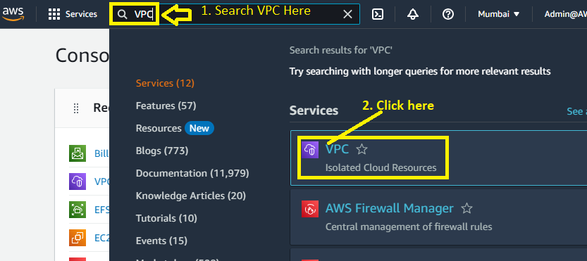

**Step 2: Go** tothe **“Security Groups”.**

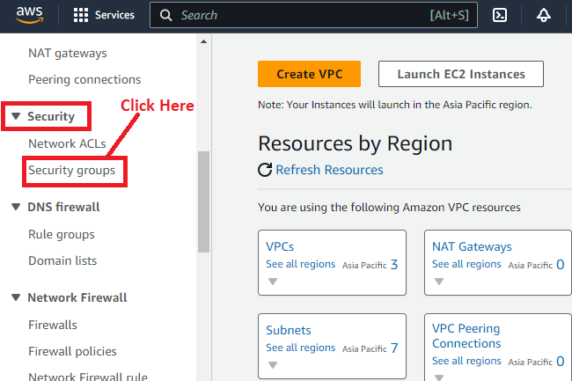

**Step 3: Click** on the **“Create security group”.**

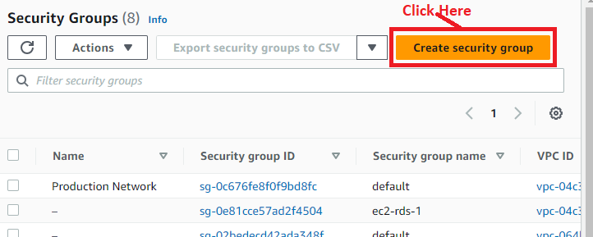

**Step 4: We** will **select** the **“Security Group Name” & “Description”** as **“MyEC2SecurityGroup”.**

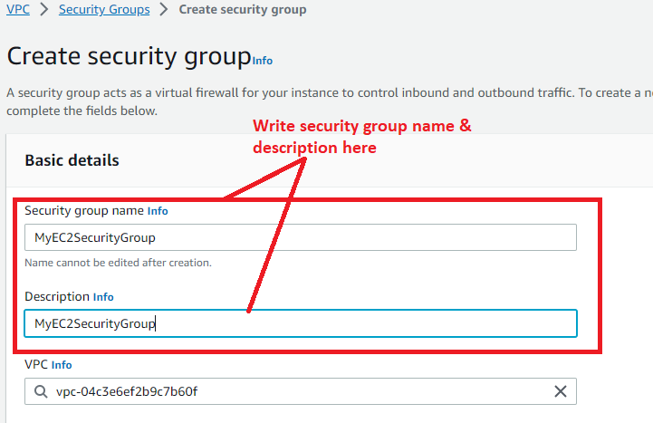

**Step 5: In** the **“Inbound Rule”, click** onthe **“Add Rule”.**

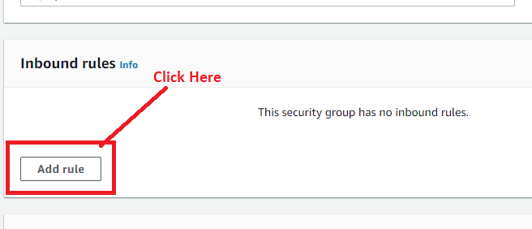

**Step 6: Choose** the **following entities** in **“Inbound Rule”** as**:**

**Type –** SSH,

**Source Type –** Anywhere-IPv4

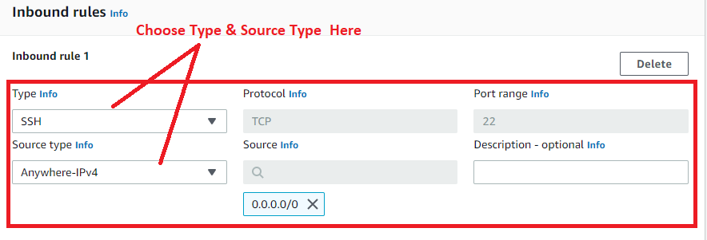

**Step 7: Go** tothe **“Manage Tags”, click** on **“Add new tag”.**

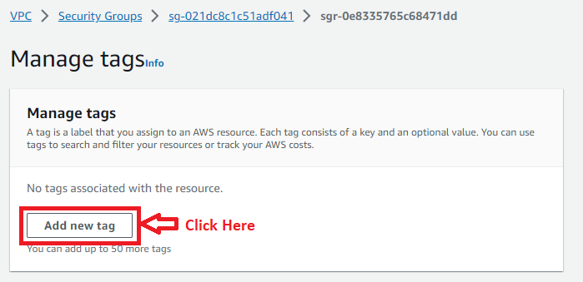

**Step 8: Put the following details here;**

**Key:** Name

**Value-optional:** MyEC2SecurityGroup

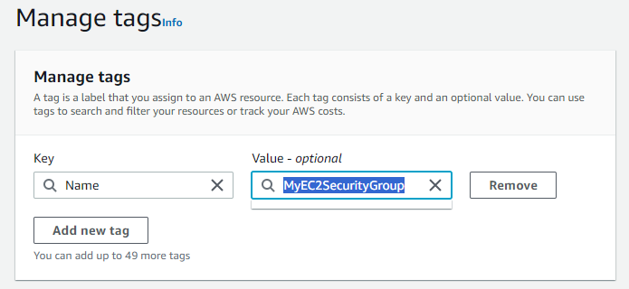

**Step 9: Leave the other settings** as **it is** & **click** on **Create security group.**

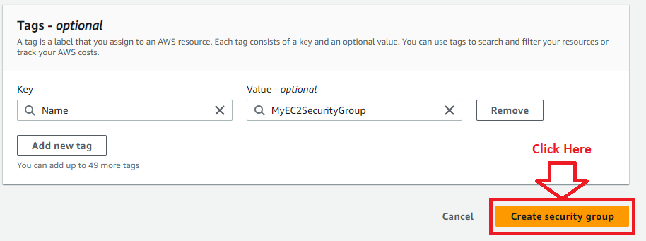

**Step 10: The security group** has been **successfully created** as **“MyEC2SecurityGroup”.**

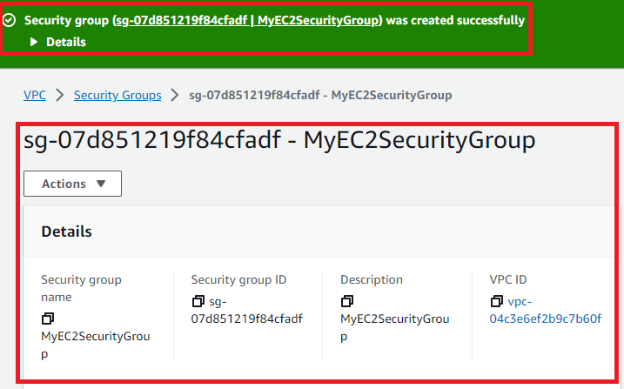

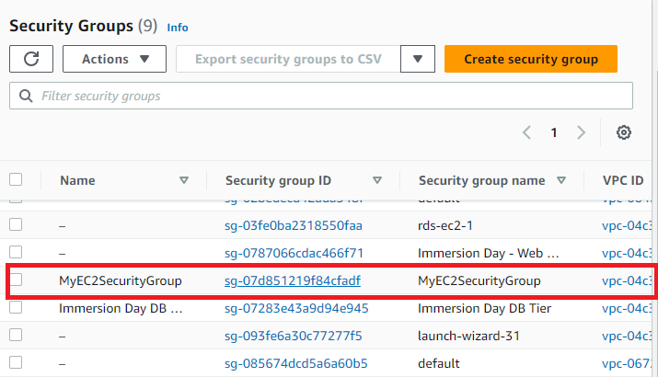

**B. Create Security Group for EFS**

**Step 1: Click** on **the** **“Create security group”.**



**Step 2: We** will **select** the **“Security Group Name” & “Description”** as **“MyEFSSecurityGroup”.**

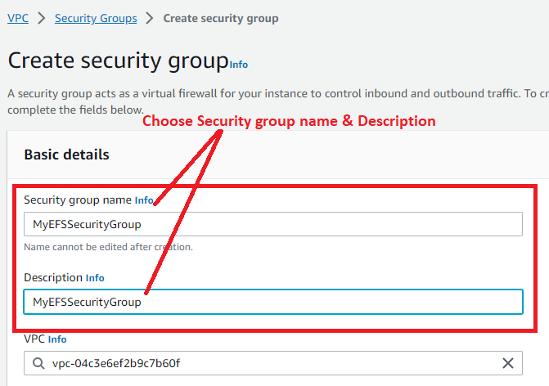

**Step 3: In** the **“Inbound Rule”, click** onthe **“Add Rule”.**



**Step 4: Choose** the **following entities** inthe **“Inbound Rule”** as**:**

**Type –** NFS,

**Source Type –** Custom

**Source -** sg-07d851219f84cfadf **(MyEC2SecurityGroup) – Security Group**

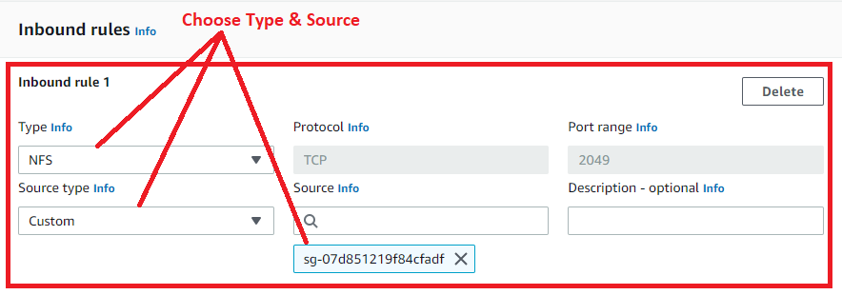

**Step 5: Go** tothe **“Manage Tags”, click** onthe **“Add new tag”.**



**Step 6: Put the following details here;**

**Key:** Name

**Value-optional:** MyEFSSecurityGroup

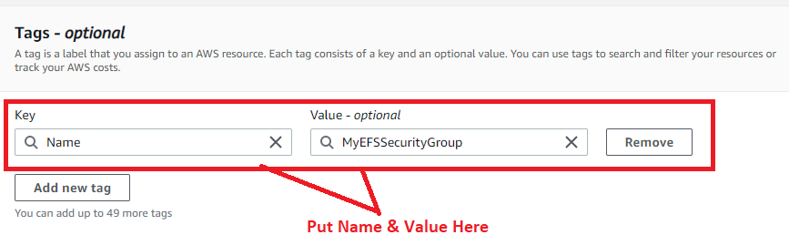

**Step 7: Click** onthe **“Create security group”.**

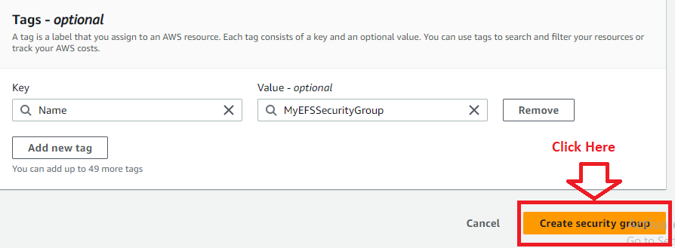

**Step 8: The security Group** has been **successfully created** as **“MyEFSSecurityGroup”.**

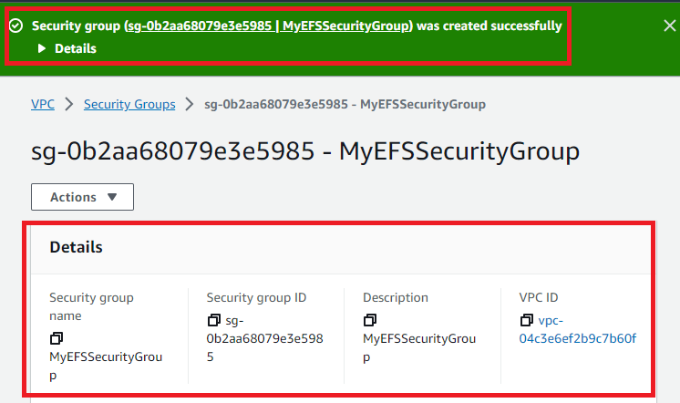

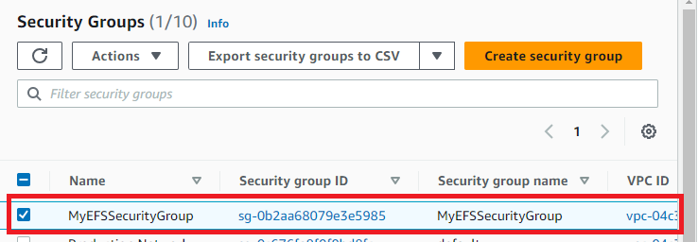

**2. Create EFS (Elastic File System)**

**Step 1: Go** to **the “Services” section** & **Search** the **“EFS”** inthe **search bar. Click** on **“EFS”.**

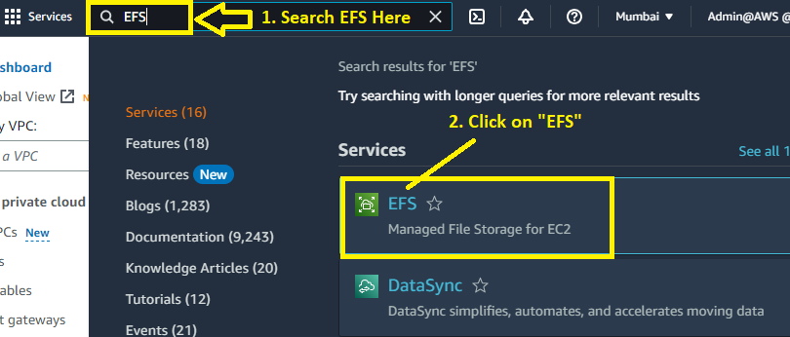

**Step 2:** **Click** on the **“Create file system”.**

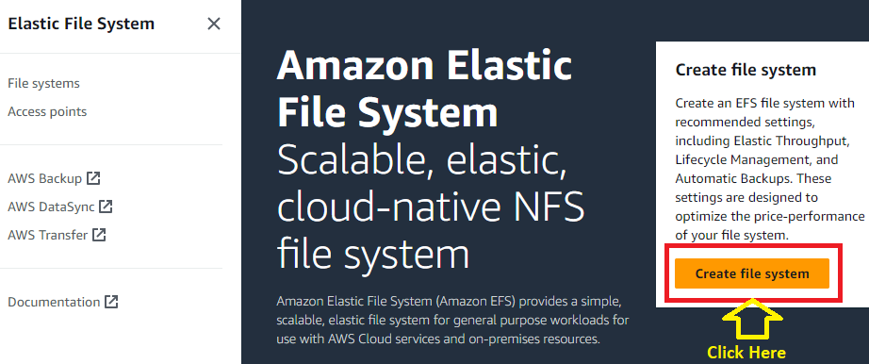

**Step 3: Choose** the **“Name-optional”** as **“MyEFSFileSystem”. Click** on the **“Create”.**

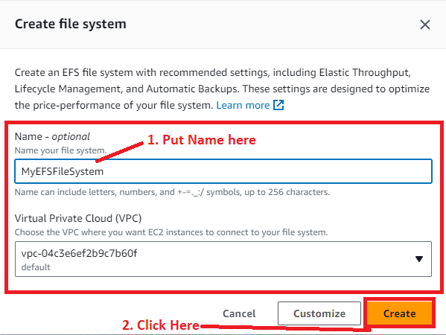

**Step 4: Your EFS File System “MyEFSFileSystem”** has been **successfully created.**

**Click** on the **“MyEFSFileSystem”** in **“Name”** section**.**

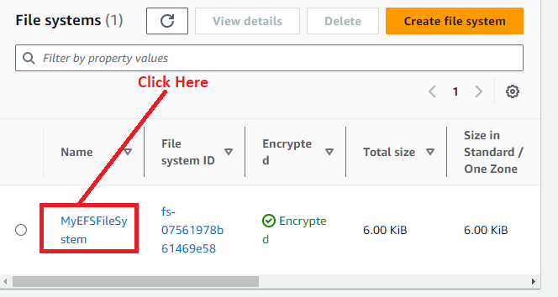

**Step 5: Click** on the **“Edit”** in the **“General” section.**

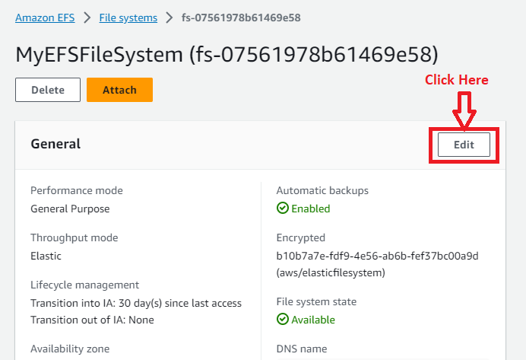

**Step 6: We** will **unselect** the **“Enable automatic backups”** inthe **“General”** section.

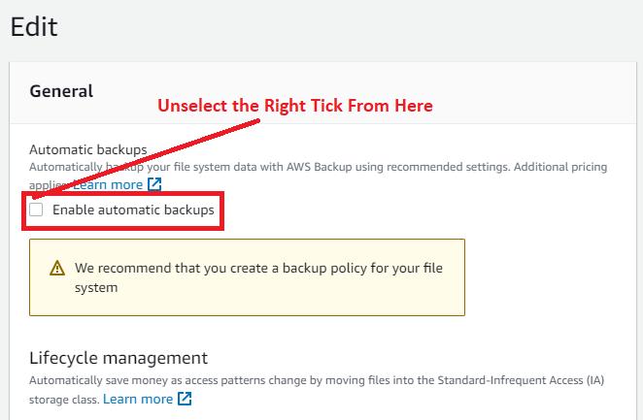

**Step 7: Leave** the **other settings** as it is **& click** on the **“Save changes”.**

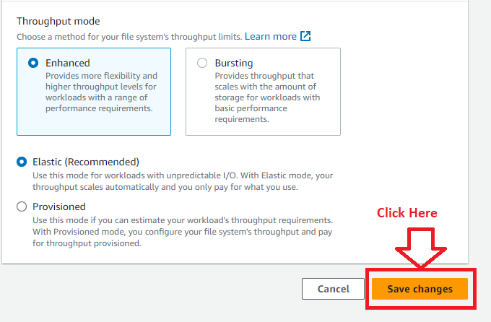

**Step 8: Your automatic back-up** will be **successfully disabled.**

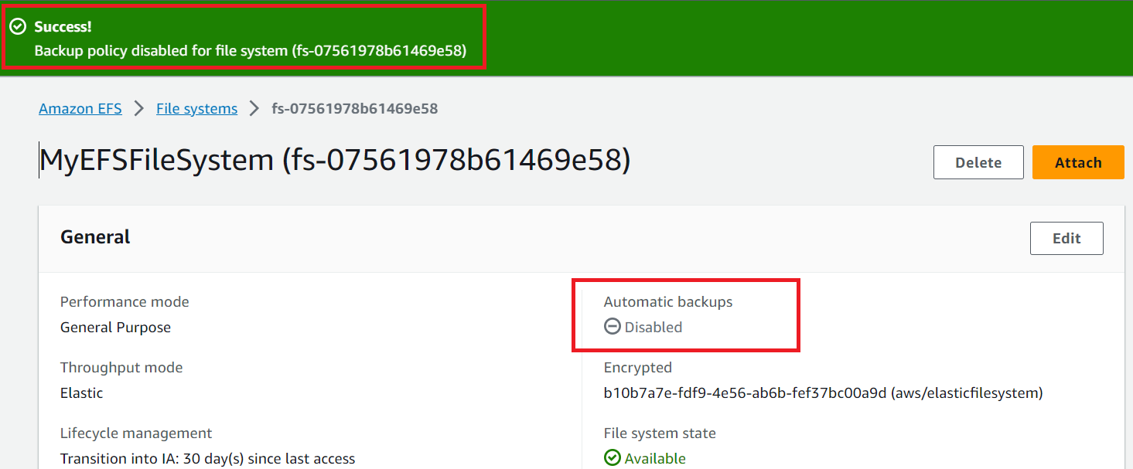

**Step 9: Go** tothe **“Network” section.**

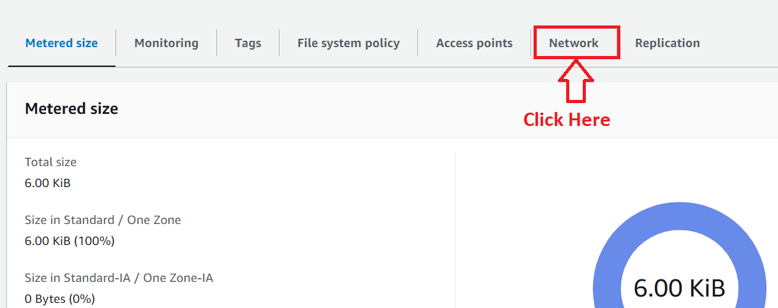

**Step 10: Click** on **“Manage”.**

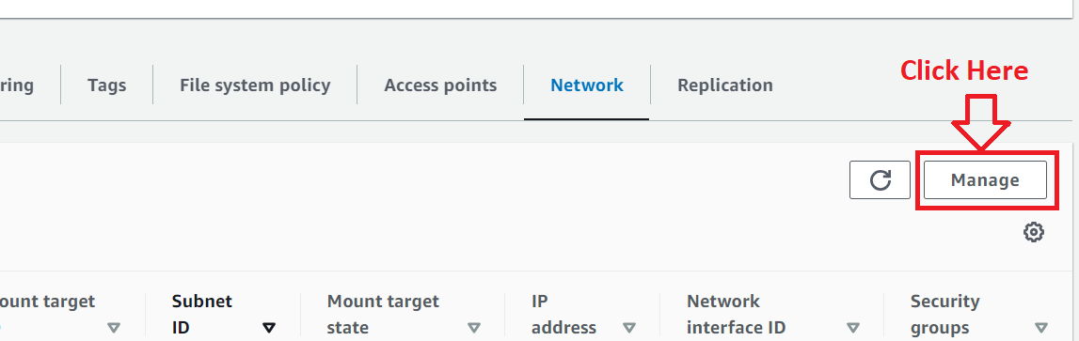

**Step 11: Remove** the **default security group.**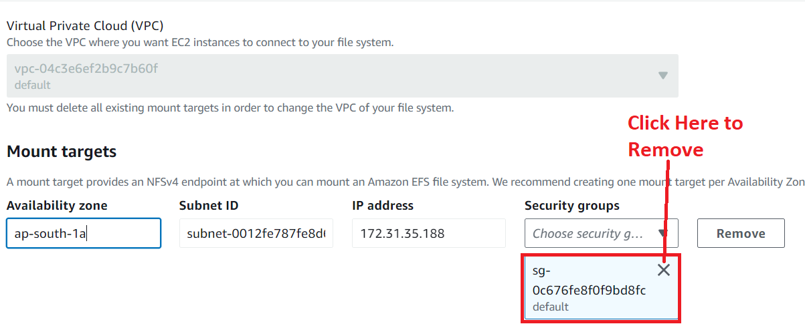

**Step 12: Add “MyEFSSecurityGroup”** in **“ap-south-1a” availability zone.**

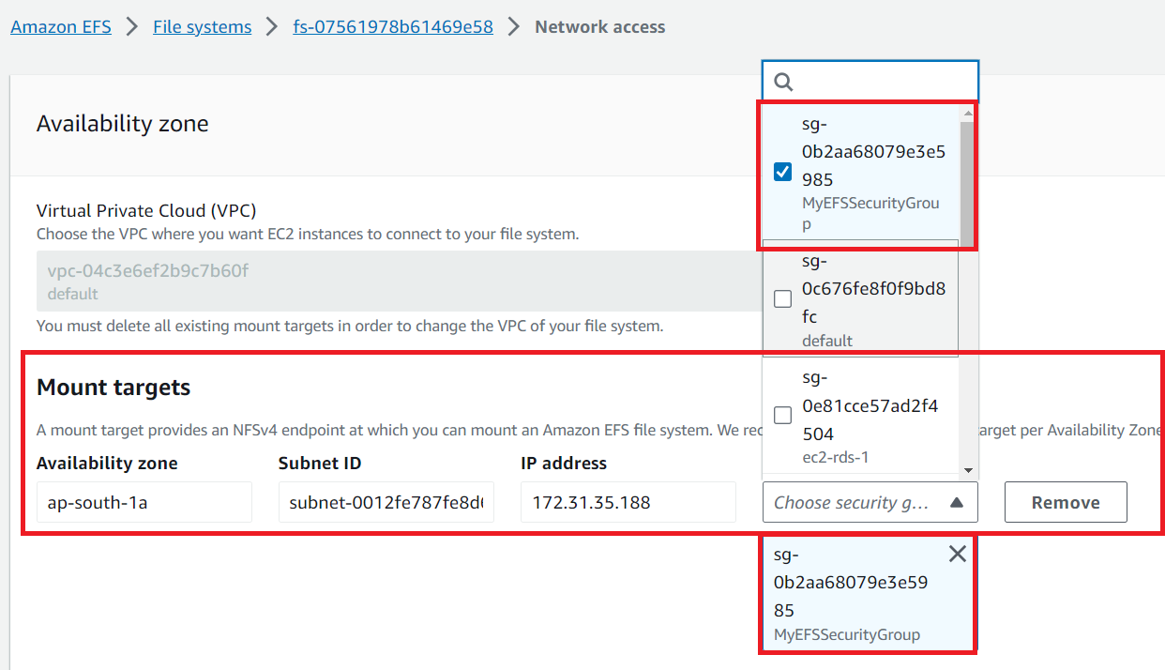

**Step 13: Click** on **“Add Mount Target”.**

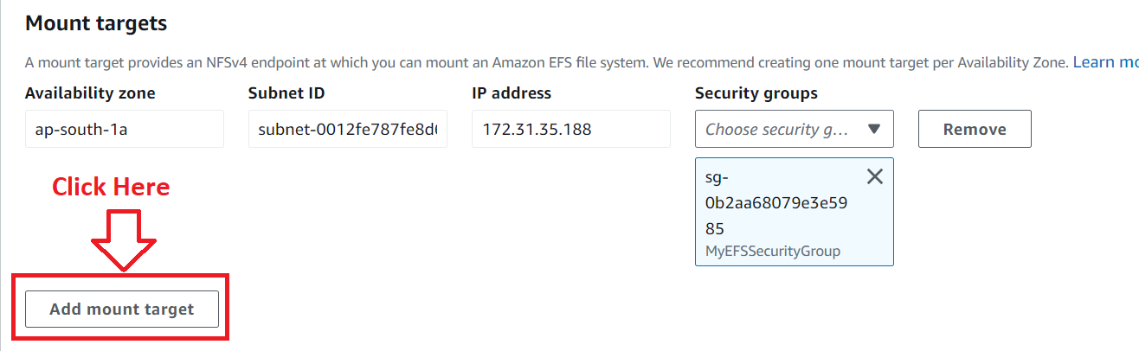

**Step 14: Add** the **“ap-south-1b”** & **“ap-south-1c”** with **“MyEFSSecurityGroups”. Also Choose subnet** in **these zones, if not created, you** must **create multiple subnets.**

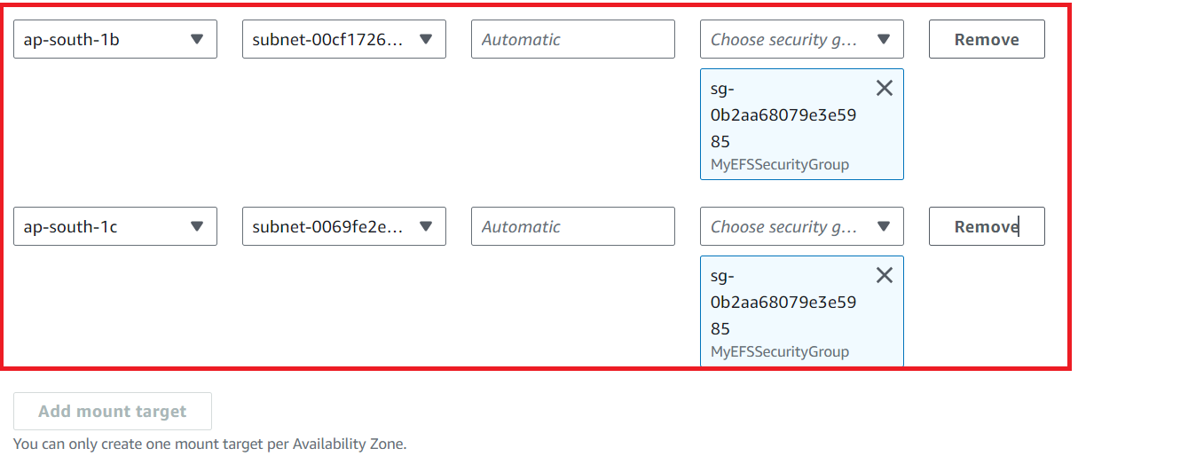

**Step 15: Click** on the **“Save”.**

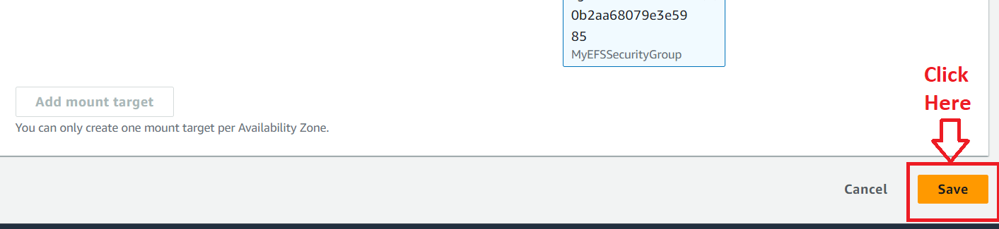

**Step 16: Your “mount target state”** is in **the “Creating” state** for **last two availability zones.**

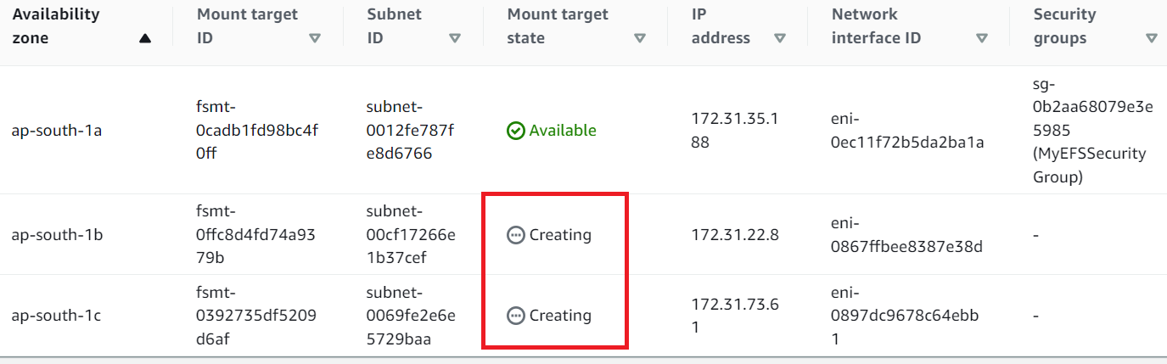

**Step 17: After sometime,** your **“Mount Target State”** is inthe **“Available” state.**

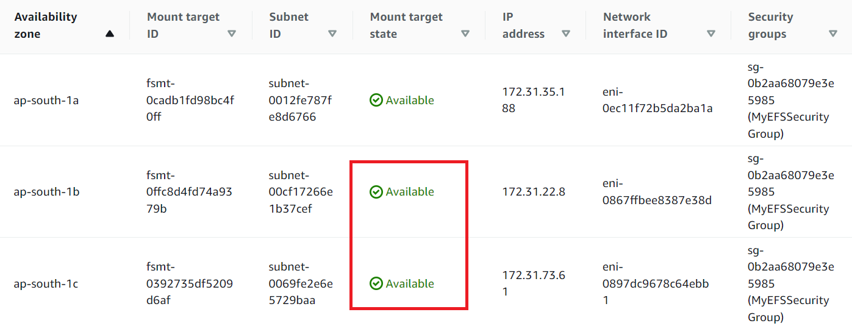

**Step 18: So,** the **“EFS”** as **“MyEFSFileSystem”** has been **successfully created.**

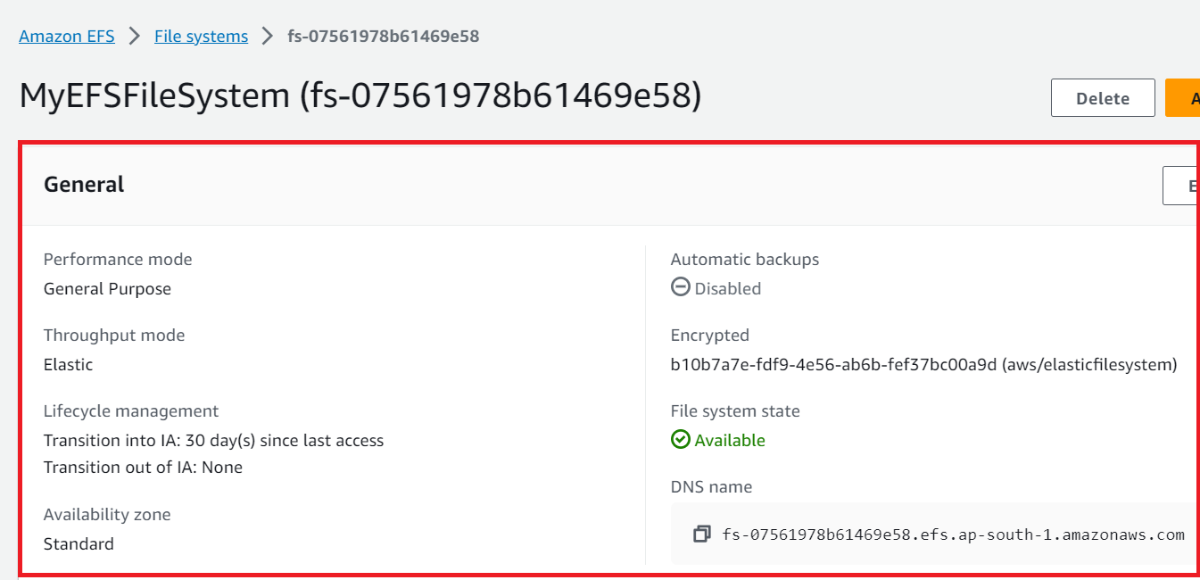

**3. Create Different EC2 Instances & Connect with EFS (Elastic File System)**

**Here, we create three different EC2 instances** with **Amazon Linux, Ubuntu** & **Redhat Enterprises** and **also connect them** with **EFS Mount** system**.**

**A. Create an EC2 Instance with Amazon Linux & Connect with EFS**

**Step 1: Go** tothe **“EC2”** service.

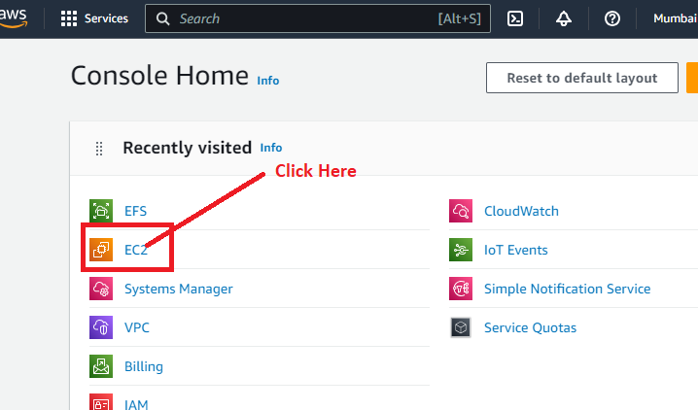

**Step 2: Click** onthe **“Instances (running)”.**

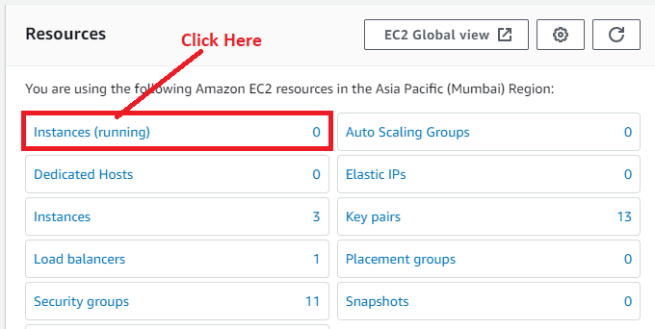

**Step 3: Click** onthe **“Launch Instance”.**

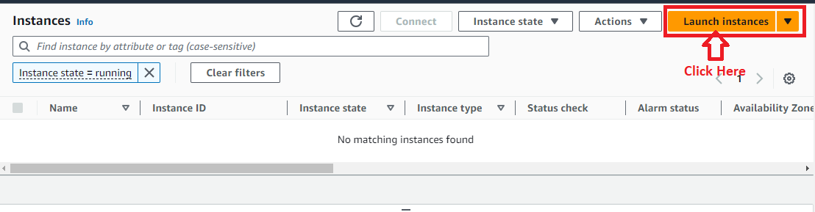

**Step 4: Choose** the **“Name”** as **“Amazon Linux EC2”** inthe **“Name and tags” section.**

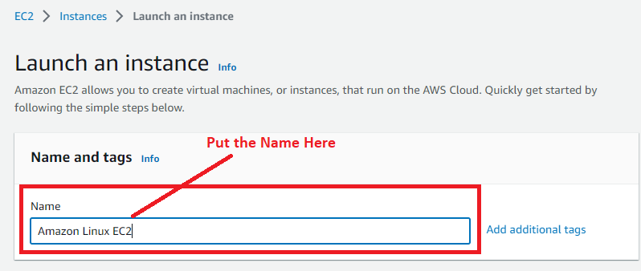

**Step 5: Choose** the **“Amazon Machine Image”** as **“Amazon Linux (aws)”.**

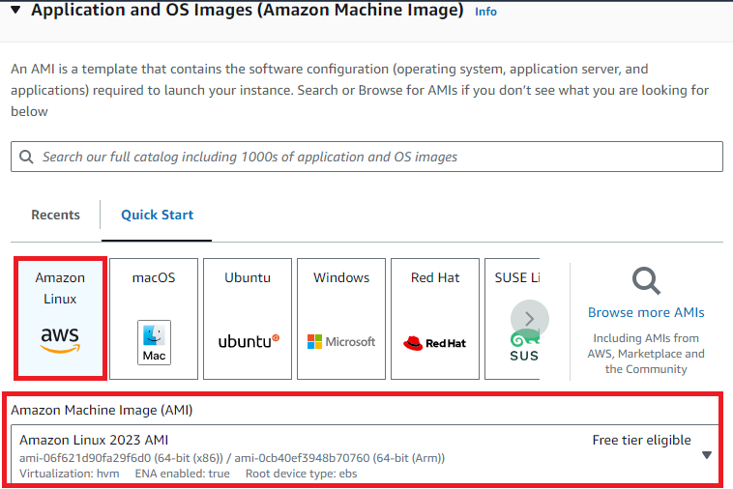

**Step 6: Choose** the **“Instance Type”** as **“t2.micro”.**

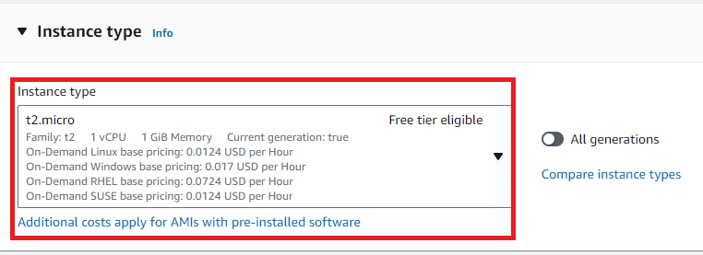

**Step 7: We have created** a **key pair “RedhatEC2”. We** will **select** this **key -pair** here**.**

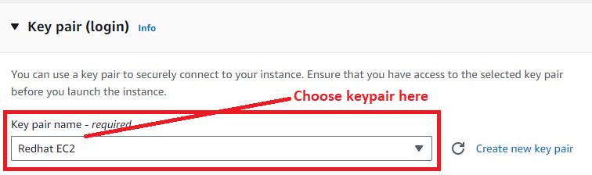

**Step 8: In the “Network settings”, click** on the **“Edit”.**

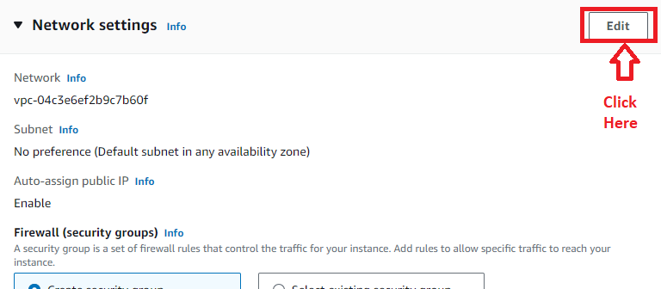

**Step 9: We** will **choose the “AWS default vpc & subnet”** here**. “Availability zone”** as **“ap-south-1a”. Leave “Auto-assign public IP”** is **enable.**

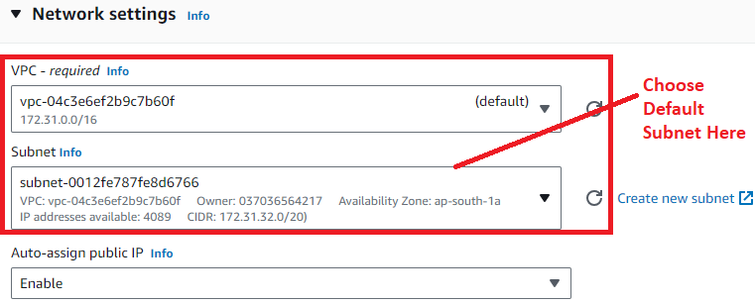

**Step 10: Choose** the **“Firewall”** asthe **“Select existing security group”. Choose** your **created security group (“MyEC2SecurityGroup”)** here**.**

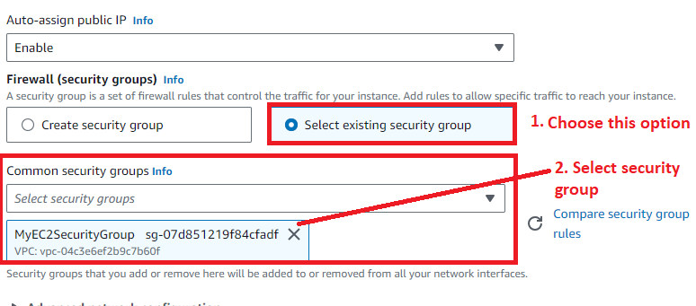

**Step 11: Leave other settings by default** & **click** on **“Launch Instance”.**

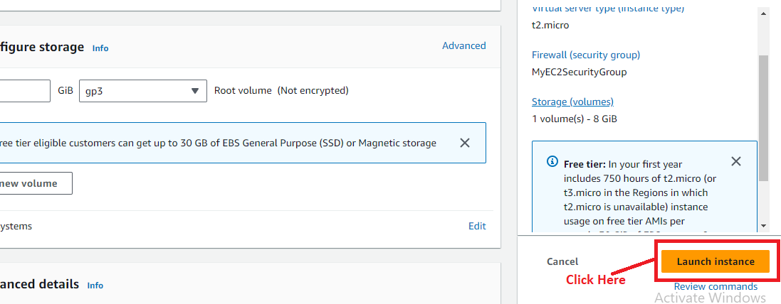

**Step 12: Click** on the **“hyperlink” or Instance id.**

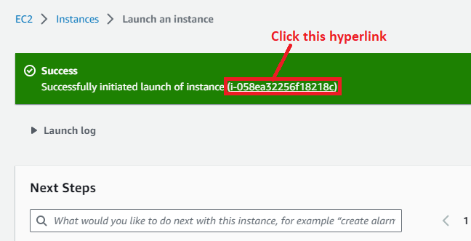

**Step 13: The "Amazon Linux EC2" Instance will be in the "Running State" like this.**

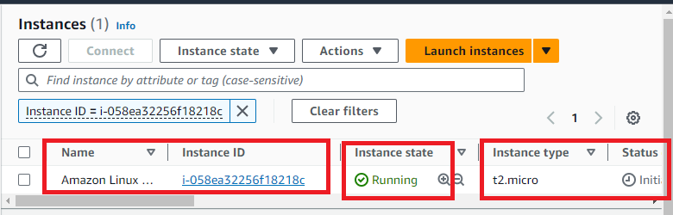

**Step 14: Select** the **Instance** & **Click** on **“Connect”.**

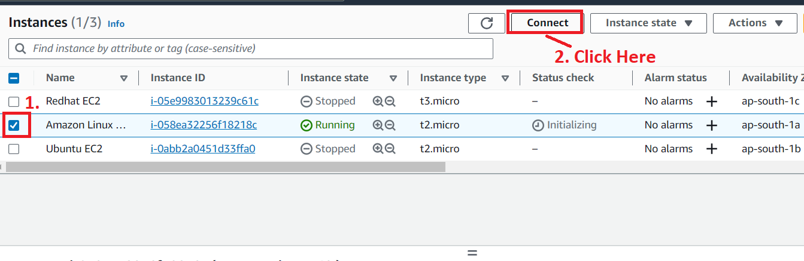

**Step 15: We will use “EC2 Instance Connect”** or **“AWS CLI”** Here**. Click** on **“Connect” button.**

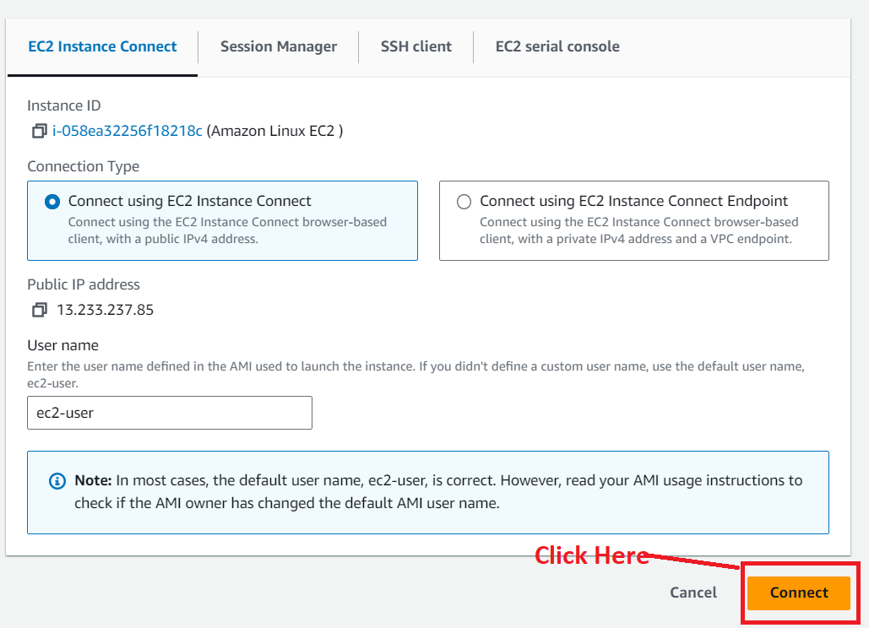

**Step 16: You** will be **successfully connected** to **the "Amazon Linux EC2"Instance here.**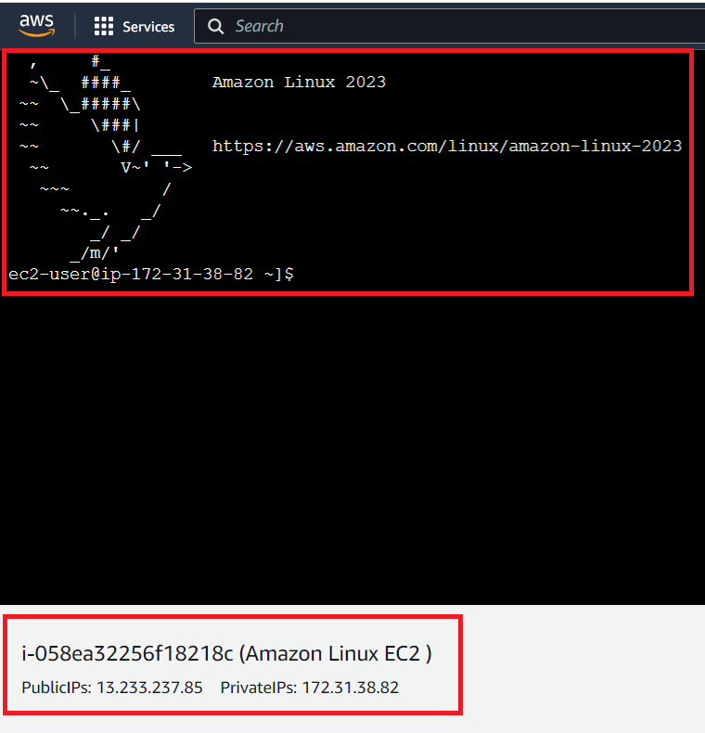

**Step 17: First, we** will **install the “Amazon EFS Utils”. Type** this **command** in **EC2 Instance Connect. (Command – sudo yum -y install amazon-efs-utils).**

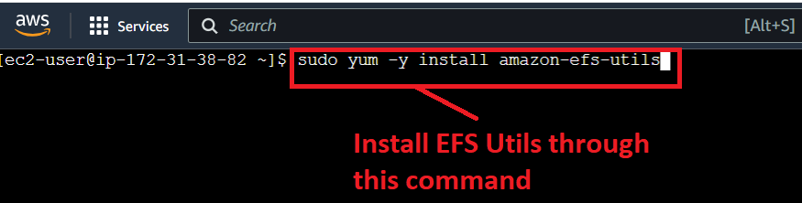

**Step 18: The “Amazon EFS Utils package”** will be **successfully installed.**

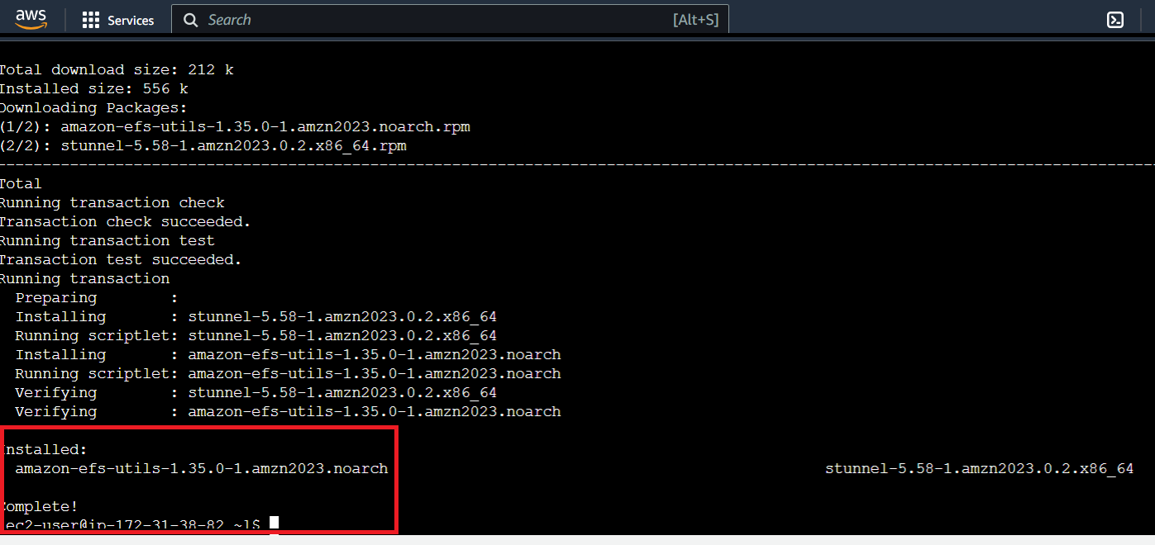

**Step 19: For creating** an **EFS directory here. Use** this **command (sudo mkdir /efs). Directory /efs** will be **successfully created.**

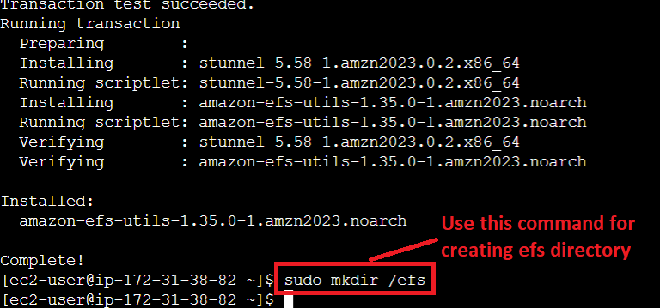

**Step 20: Now, for building** the **EFS mount, open** your **EFS File (“MyEFSFileSystem”). Click** on the **“MyEFSFileSystem”.**

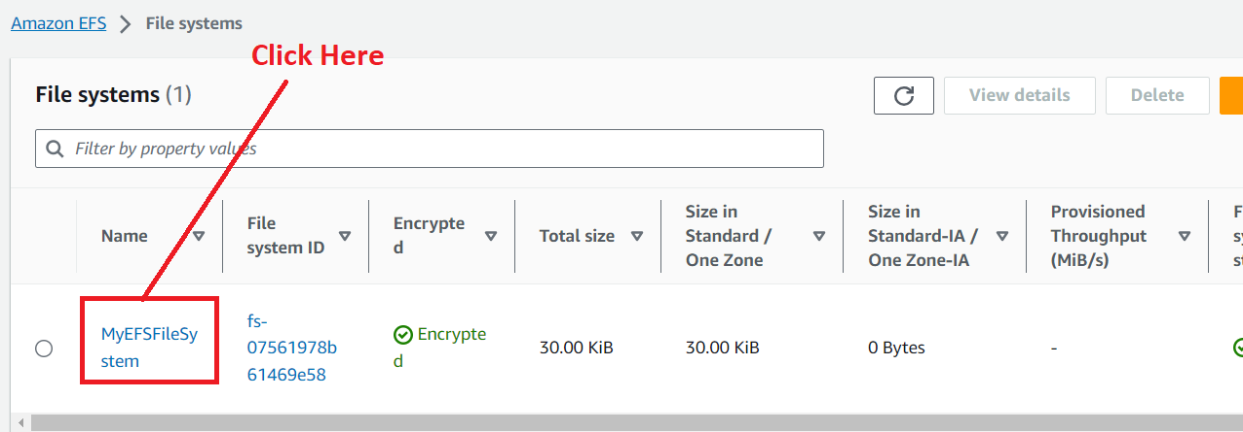

**Step 21: Click** on **“Attach”.**

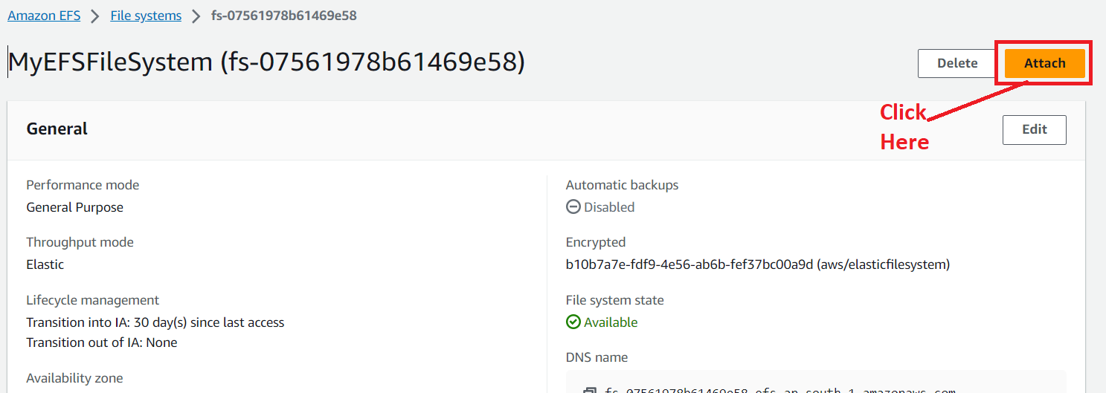

**Step 22: Copy the Given Command from “EFS mount helper” system.**

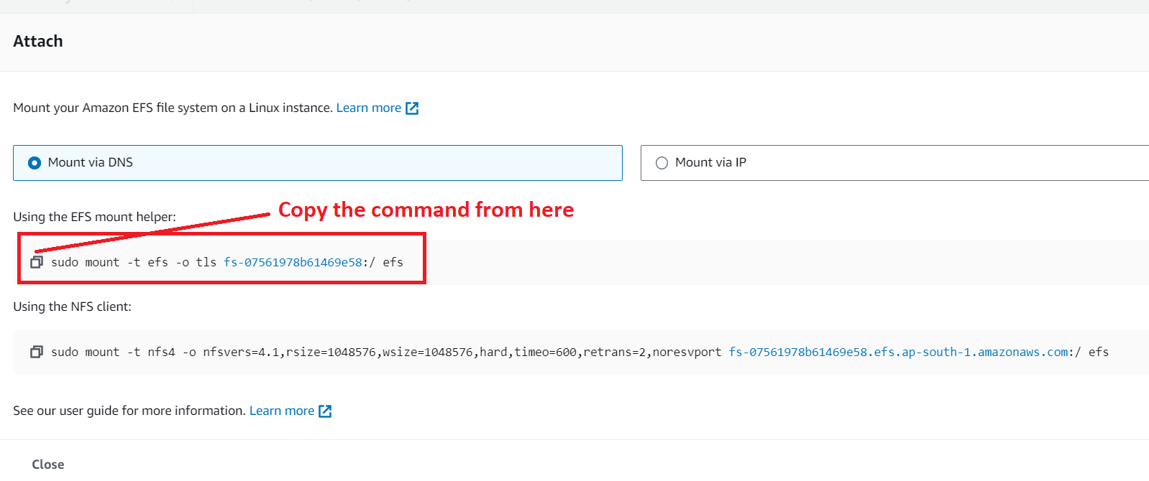

**Step 23: Paste** the **“mount command”** in the **“EC2 Instance Connect”. Replace efs** with **/efs** then **hit enter** from **keyboard.**

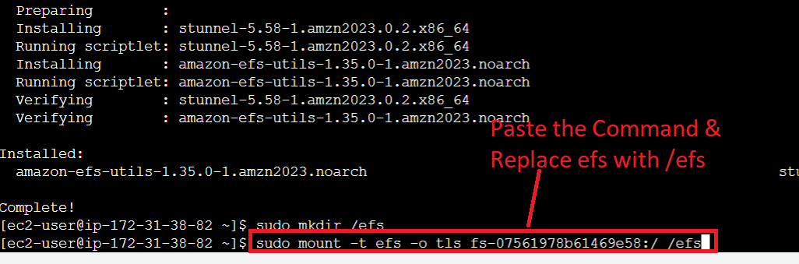

**Step 24: Now, run** the **“df -h” command** to **check** that **EFS Mount** is **build or not. The “/efs” directory** will be **shown here; it** means **your EFS mount** is **successfully build.**

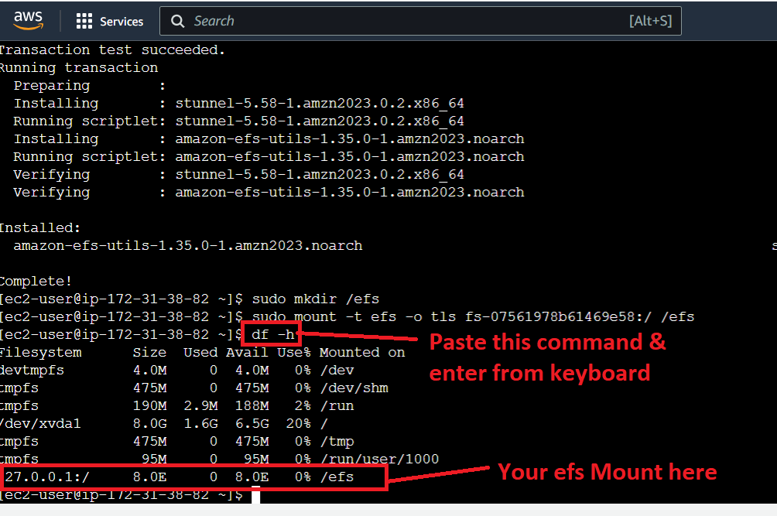

**Step 25: Now, we** will gointo **the /efs by “cd /efs” command.**

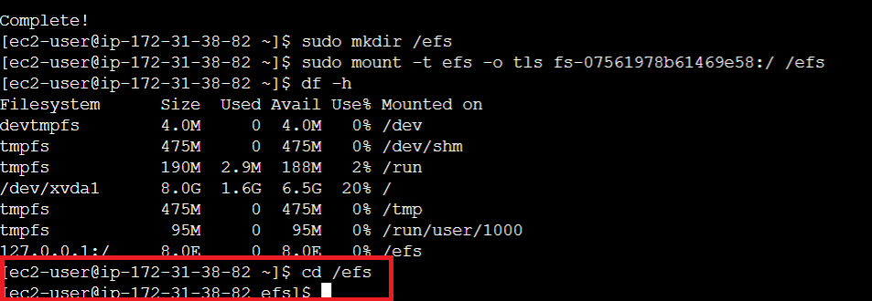

**Step 26: Now, create** a **“hello” directory** by using **“sudo mkdir hello”** command**.**

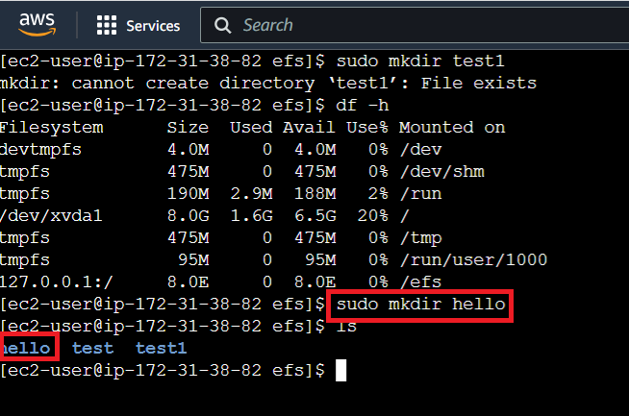

**Step 27: Now** do **“cd hello”** to **change** the **directory** & **go** insideinto **“hello”** directory.

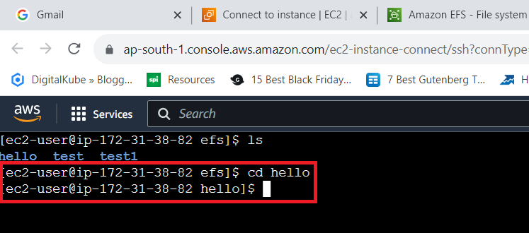

**Step 28: Now, create** the **“hello.txt” file** using **‘sudo echo hello.txt’ command.**

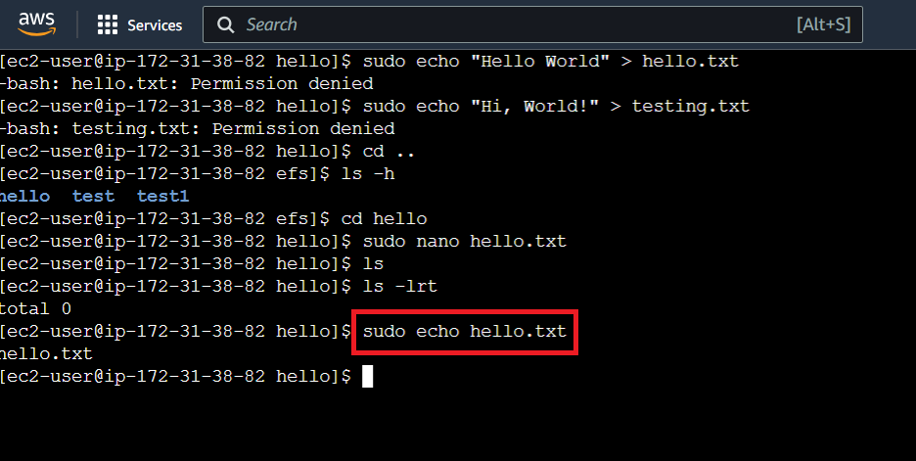

**Step 29: Now, we** will **put** the **content inside** the **“hello.txt” file. First, we** will **open** this **file** using **‘sudo nano hello.txt”** command**.**

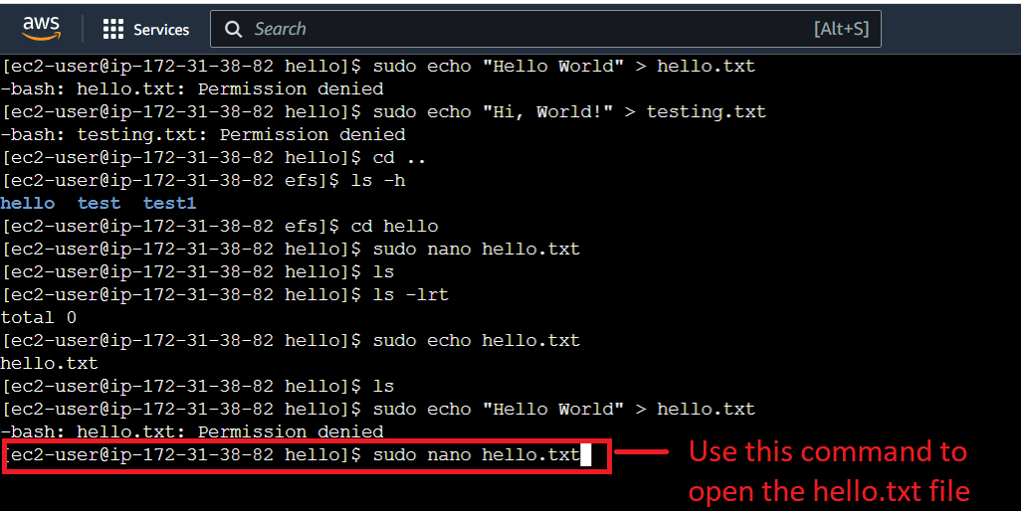

**Step 30: Now, put** your **content** in the **file** & **do CTRL+X, Press Y** from **keyboard** for **“Yes”** & **press** the **enter button** to **exit the file.**

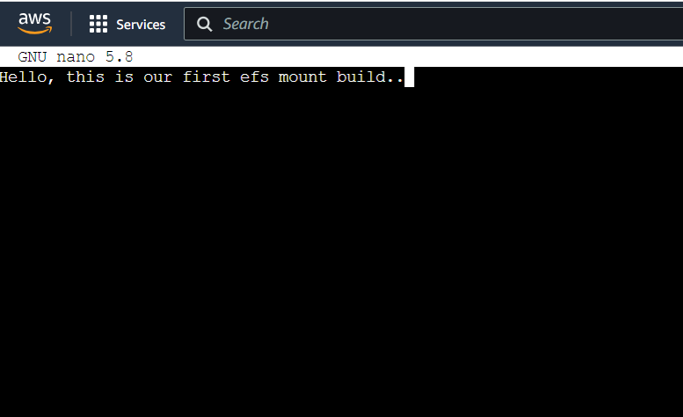

**Step 31: To check** the **content** of **hello.txt file, use** this **command: “cat hello.txt”. Your content** will be **shown & the efs** will be **successfully build** to **store** the **data.**

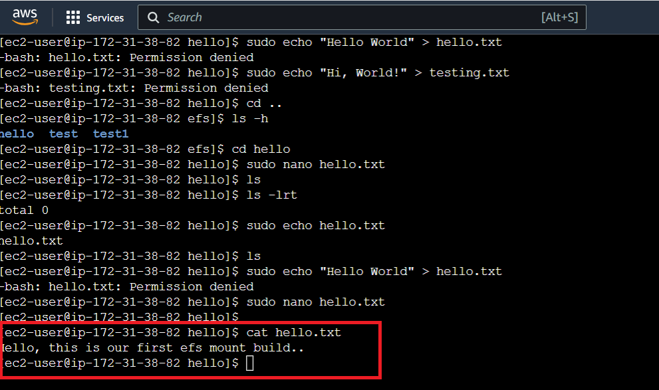

**This** means **we** have **successfully mounted** on the **Amazon Linux 2 Instance** & **connected the EC2 with EFS.**

**B. Create an EC2 Instance with Ubuntu & Connect with EFS**

**Step 1: Click** onthe **“Launch Instance”.**



**Step 2: Choose** the **“Name”** asthe **“Ubuntu EC2”** inthe **“Name and tags” section.**

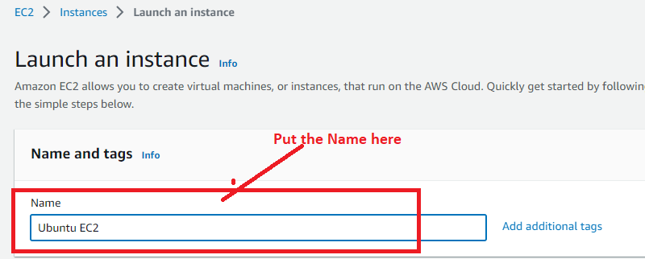

**Step 3: Choose “Amazon Machine Image”** as **“Ubuntu”.**

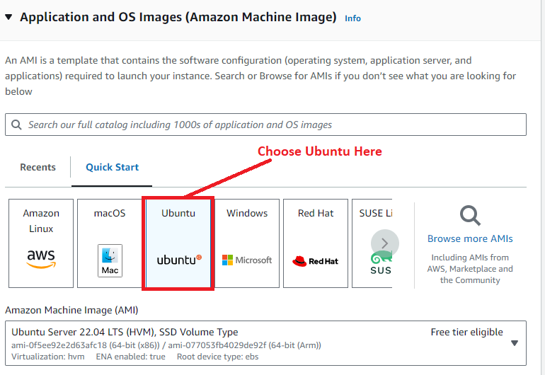

**Step 4: Choose** the **“Instance Type”** as **“t2.micro”.**



**Step 5: We have created** a **key pair “RedhatEC2”. We** will **select** this **key -pair** here**.**



**Step 6: In** the **“Network settings”, click** on **“Edit”.**



**Step 7: We** will **choose** the **“AWS default vpc” & “Created subnet (Zone_B)”** here**. “Availability zone”** as **“ap-south-1b”. Leave “Auto-assign public IP”** is **Enable.**

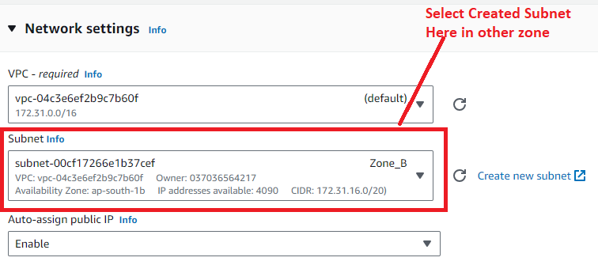

**Step 8: Choose “Firewall”** as **“Select existing security group”. Choose** your **created security group (“MyEC2SecurityGroup”)** here**.**



**Step 9: Leave other settings by default** & **click** on **“Launch Instance”.**



**Step 10: Click** on the **“hyperlink” or Instance id.**

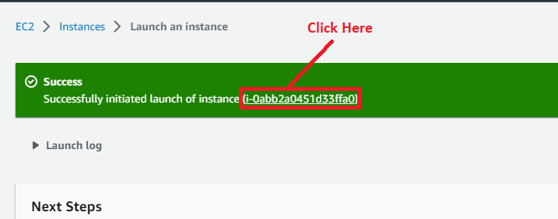

**Step 11: Your running "Ubuntu EC2 Instance" will be shown like this:**

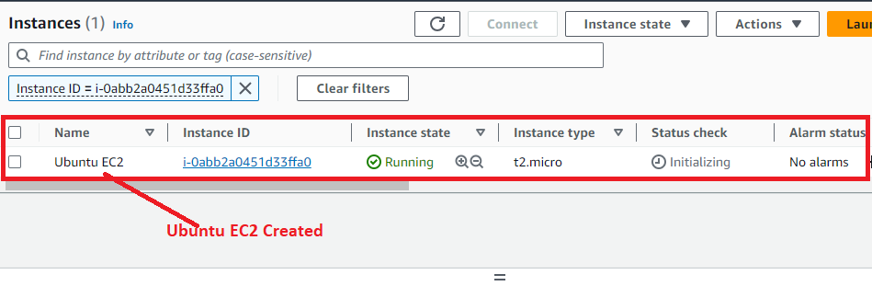

**Step 12: Select** the **Instance** & **Click** on **“Connect”.**

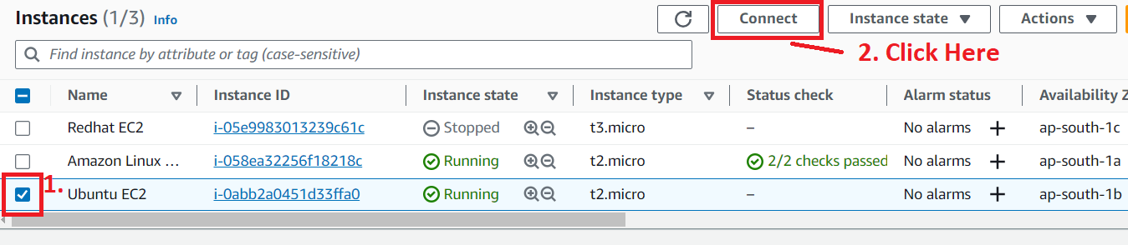

**Step 13: We will use “EC2 Instance Connect”** here**. Click** onthe **“Connect”.**

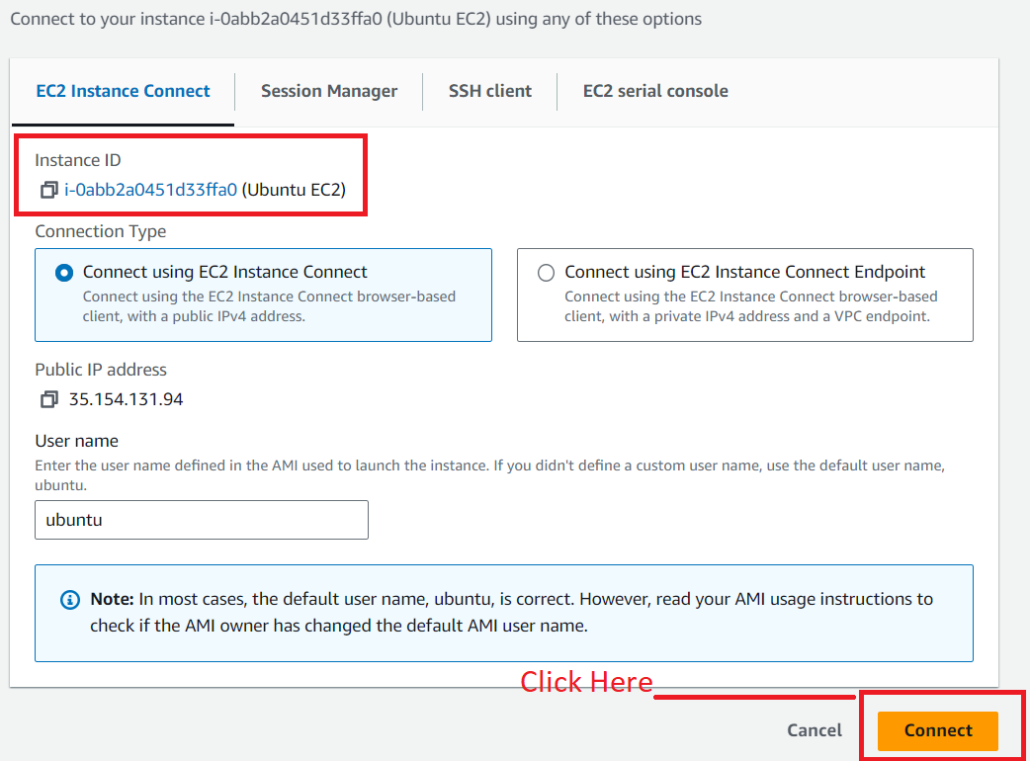

**Step 14: You** will be **successfully connected** to the **SSH Instance here.**

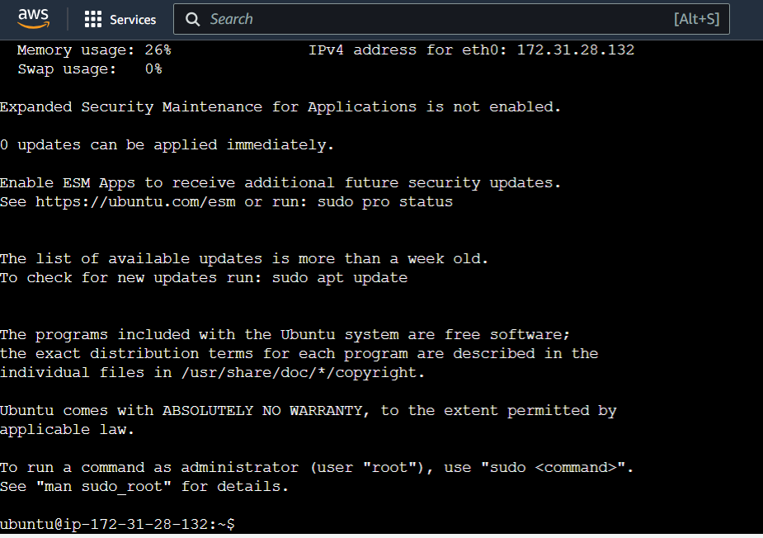

**Step 15: Use “sudo apt-get update” command** to **update** the **“Ubuntu Software”.**

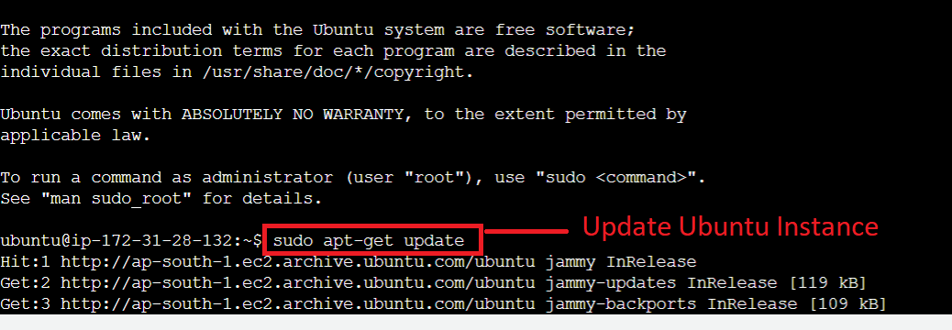

**Step 16: First, we** will **install** the **“NFS Common Client”. Type** this **command** in **the “Ubuntu EC2 Instance Connect”. (Command – sudo apt-get -y install nfs-common).**

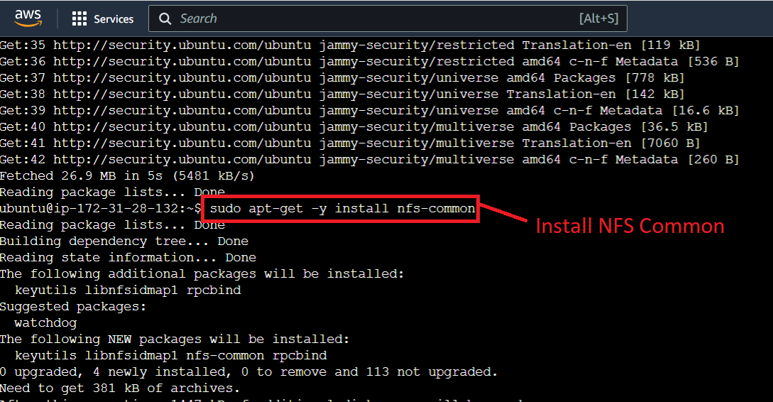

**Step 17:** The **“Amazon NFS Common”** will be **successfully installed.**

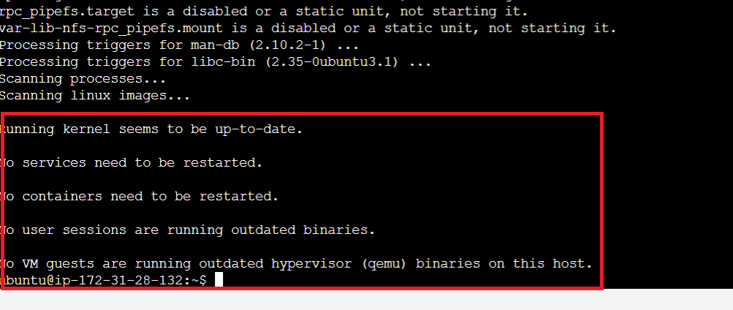

**Step 18: For creating** an **EFS directory here. Use** this **command (sudo mkdir new_dir). Directory new_dir** will be **successfully created.**

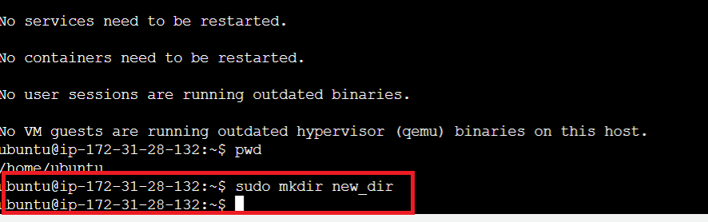

**Step 19: Now, for building** the **EFS mount, open** your **EFS File (“MyEFSFileSystem”). Click** on **“MyEFSFileSystem”.**



**Step 20: Click** on **“Attach”.**



**Step 21: Copy the Given Command from “NFS Client” system.**

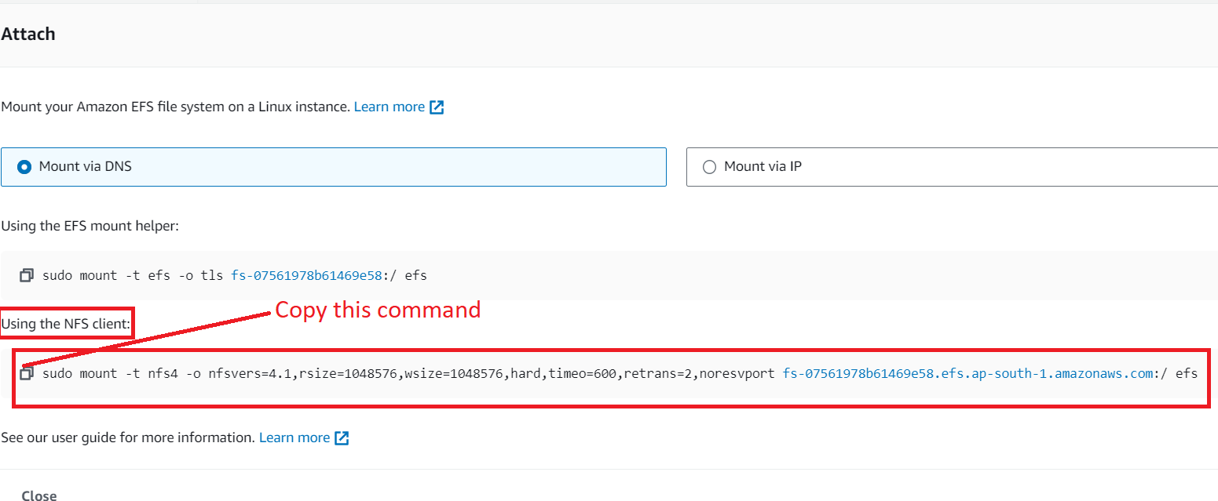

**Step 22: Paste** the **“mount command”** in **“Amazon CLI”. Replace efs** with **new_dir** then **hit enter** from **keyboard.**

**Command: - “sudo mount -t nfs4 -o nfsvers=4.1,rsize=1048576,wsize=1048576,hard,timeo=600,retrans=2,noresvport fs-07561978b61469e58.efs.ap-south-1.amazonaws.com:/ new_dir”**

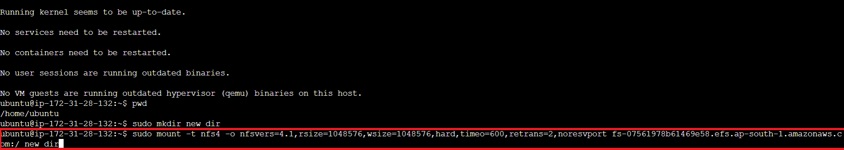

**Step 23: Now, run** the **“df -h” command** to **check** that **EFS Mount** is **build or not. The “new_dir” directory** will be **shown here, it** means **your EFS mount** is **successfully build.**

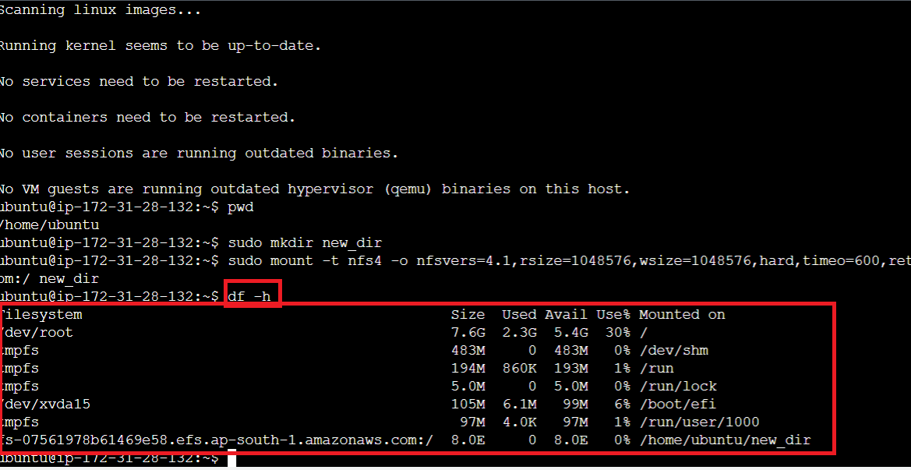

**Step 24: Now,** wewill gointo **new_dir** by **using** the **“cd new_dir” command.**

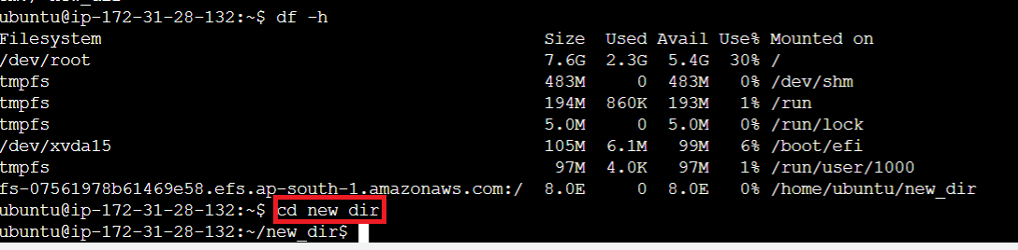

**Step 25: Now, create** a **“test” directory** by using **the sudo mkdir test”** command**.**

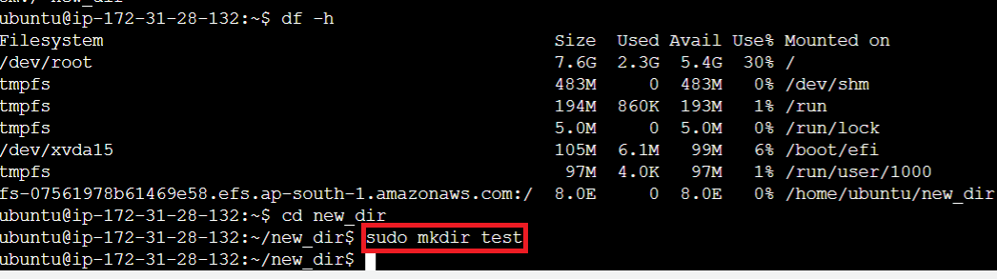

**Step 26: Now** do **“cd test”** to **change** the **directory** & **go** insideinto the **“test”** directory.

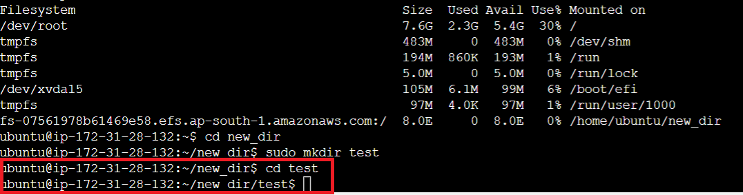

**Step 27: Now, create** the **“test.txt” file** usingthe **‘sudo echo test.txt’ command.**

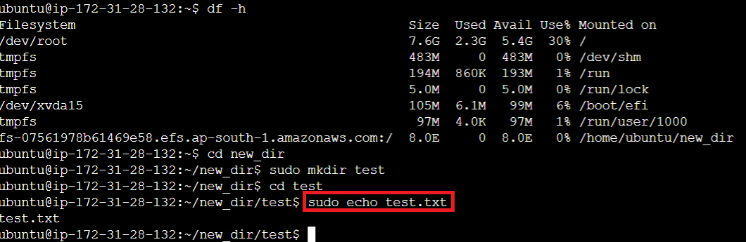

**Step 28: Now, we** will **put** the **content inside** the **“test.txt” file. First, we** will **open** this **file** using the **‘sudo nano test.txt”** command**.**

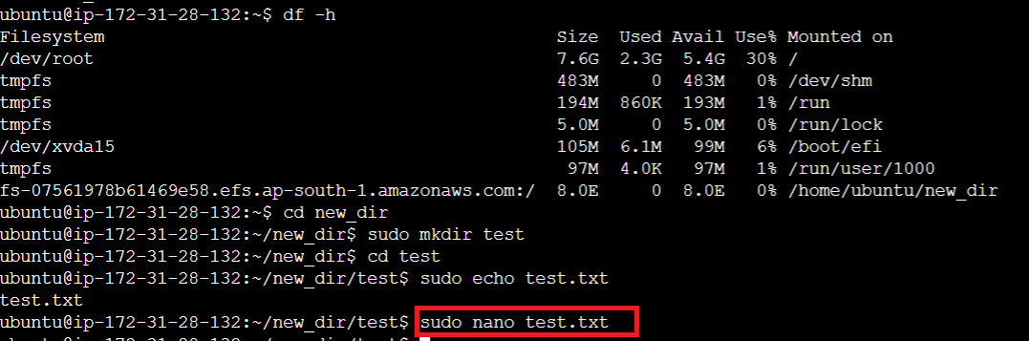

**Step 29: Now, put** your **content** in the **file** & **do CTRL+X, Press Y** from **keyboard** for **“Yes”** & **press** the **enter button** to **exit the file.**

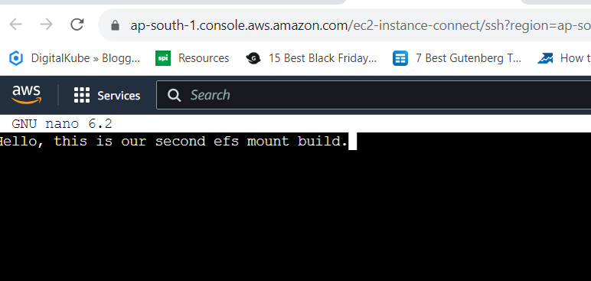

**Step 30: To check** the **content** of **hello.txt file, use** this **command: “cat test.txt”. Your content** will be **shown &** the **efs** will be **successfully build** to **store** the **data.**

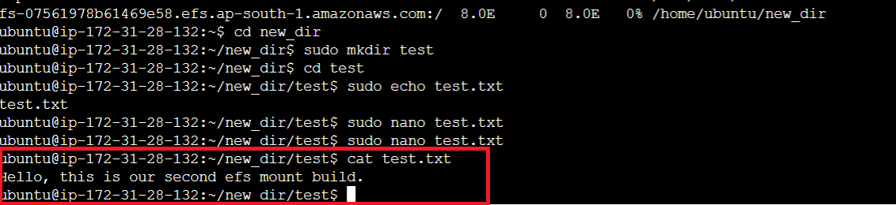

**Step 31:** **Now,** we will go to “**new_dir”** by **this command** **“cd ..**”.

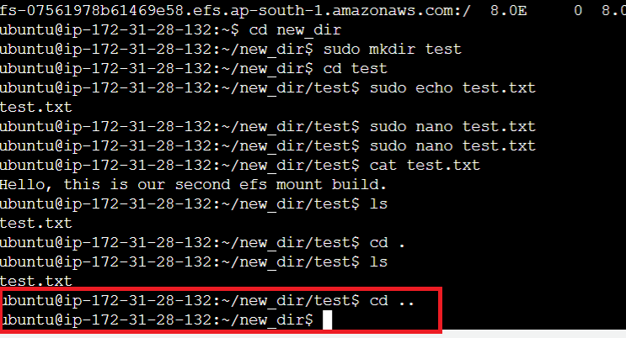

**Step 32: When** we will **do “ls -lrt” command, we** will **get first EFS mount directory** & **Current EFS directory here. We** have **removed** the **test directory** from **first EFS mount** & **create** the **“hello”** directory**.**

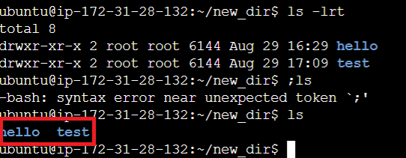

**Step 33: If we** go to **Amazon Linux instance** & **run** the **“ls” command** in the **/efs directory, we** will **get both** the **directories (test & hello)** here.

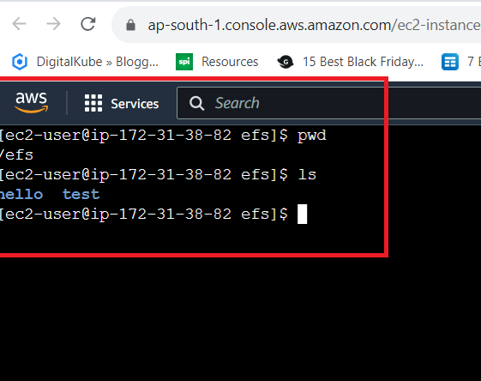

**This means we have successfully mount on Ubuntu & Connect the EC2 with EFS.**

**C. Create an EC2 Instance with Redhat & Connect with EFS**

**Step 1: Click** onthe **“Launch Instance”.**



**Step 2: Choose** the **“Name”** as **“Redhat EC2”** inthe **“Name and tags”** section.

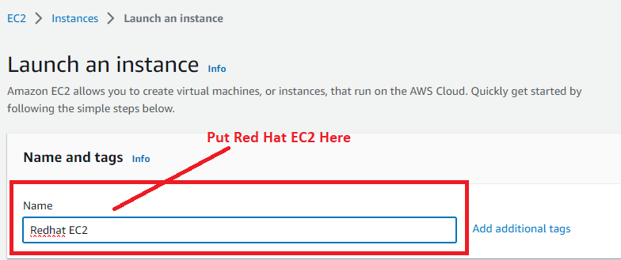

**Step 3: Choose** the **“Amazon Machine Image”** as **“Red Hat”.**

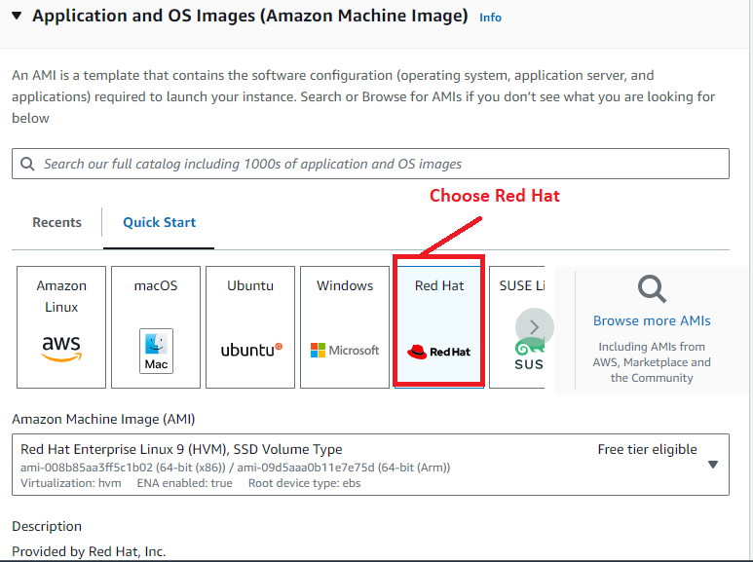

**Step 4: Choose** the **“Instance Type”** as **“t3.micro”.**

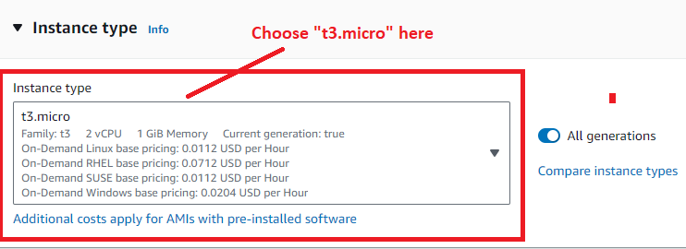

**Step 5: We have created** a **key pair “RedhatEC2”. We** will **select** this **key -pair** here**.**



**Step 6: In** the **“Network settings”, click** on the **“Edit”.**



**Step 7: We** will **choose** the **“AWS default vpc” & “Created subnet (Zone_C)”** here**. Choose** the **“Availability zone”** as **“ap-south-1c”. Leave** the **“Auto-assign public IP”** is **enable.**

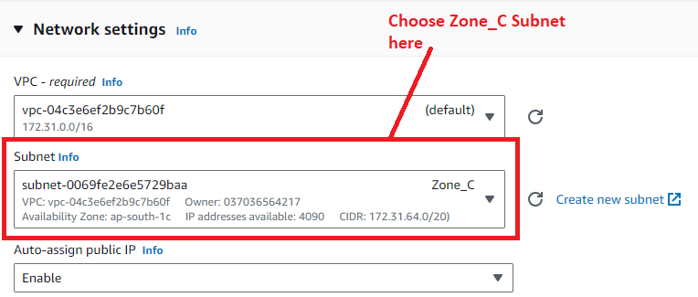

**Step 8: Choose** the **“Firewall”** as **“Select existing security group”. Choose** your **created security group (“MyEC2SecurityGroup”)** here**.**



**Step 9: Leave** the **other settings by default** & **click** on the **“Launch Instance”.**



**Step 10: Click** on the **“hyperlink”** or **Instance id.**

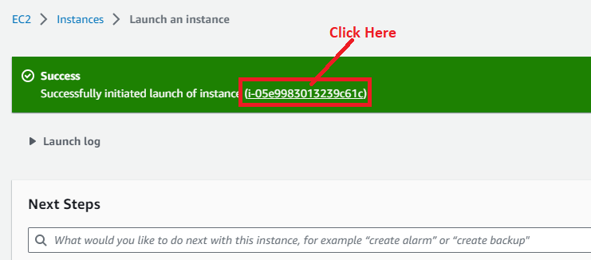

**Step 11: Your instance (Redhat EC2) will be in the “Running” state:**

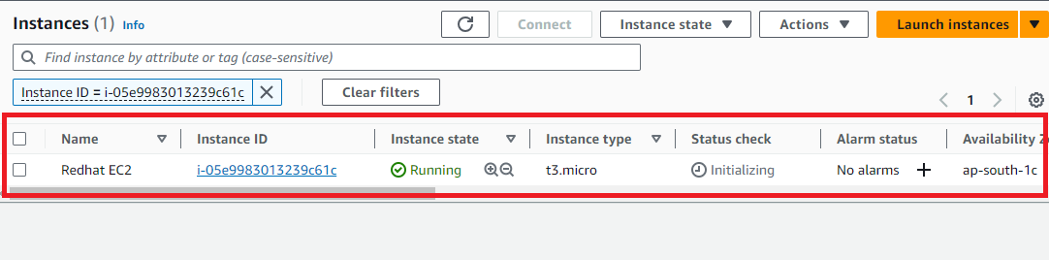

**Step 12: Select** the **“Redhat EC2”** & **Click** onthe **“Connect”.**

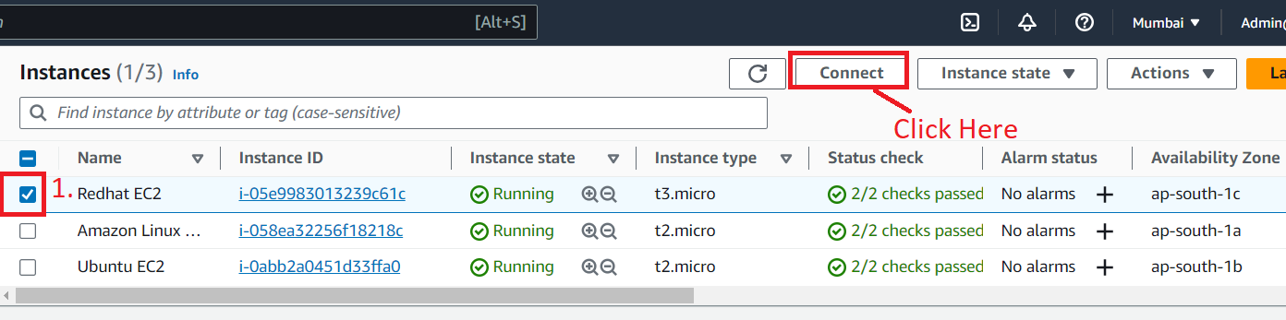

**Step 13: Go** to the **“SSH Client” & copy** the **given command** under **the “Example” section.**

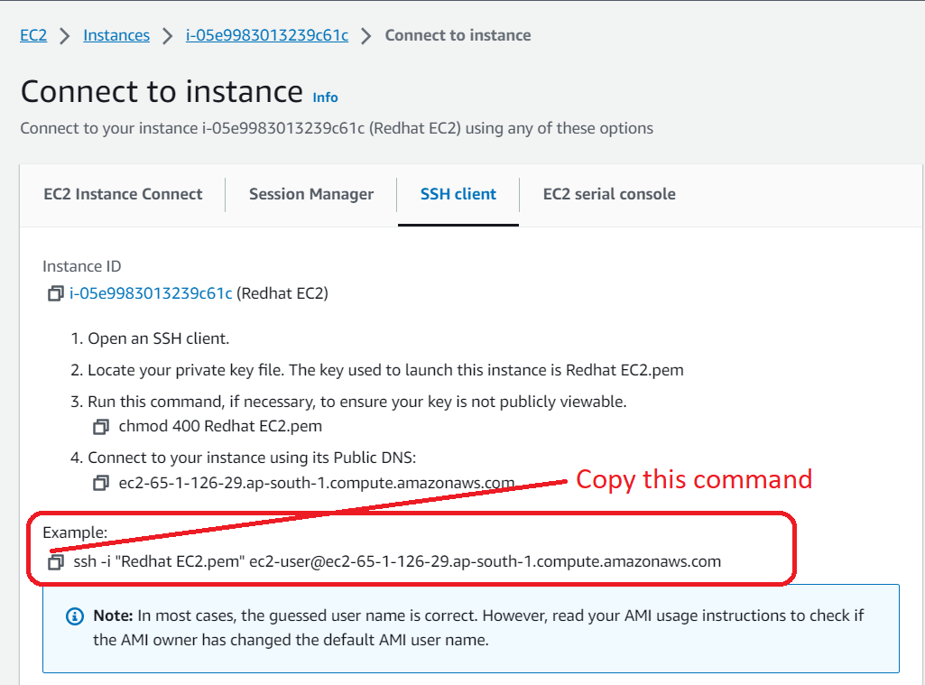

**Step 14: Open** the **“Command Prompt” from** the **computer. Run** the **“cd Downloads” command because our “Redhat EC2” pem file present here.**

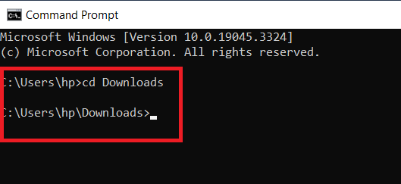

**Step 15: Paste** the **given command over** here & **press enter** from the **keyboard.**

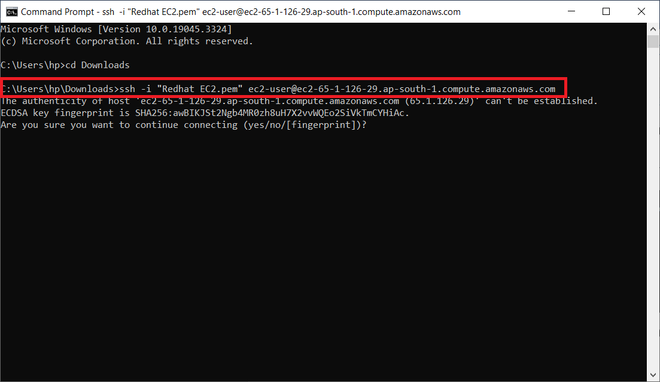

**Step 16: Type “Yes” & Press enter from the keyboard. You will be successfully connected to your instance.**

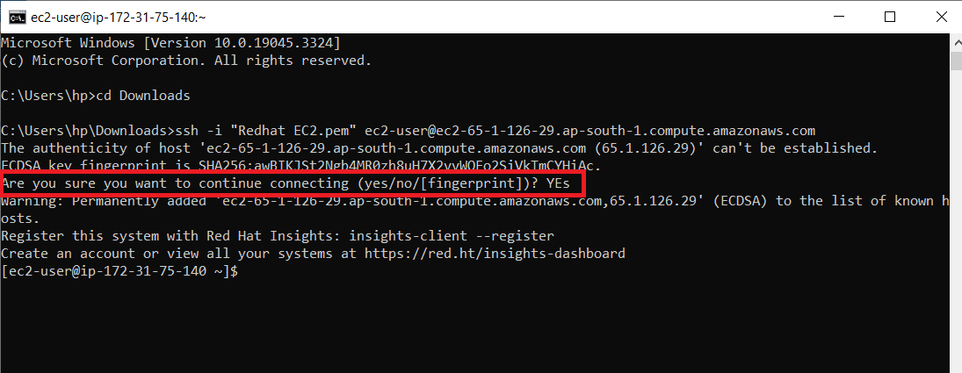

**Step 17: Run** this **command** to **install nfs utils. (Command: - sudo yum -y install nfs-utils). The “NFS Utils”** will be **successfully installed.**

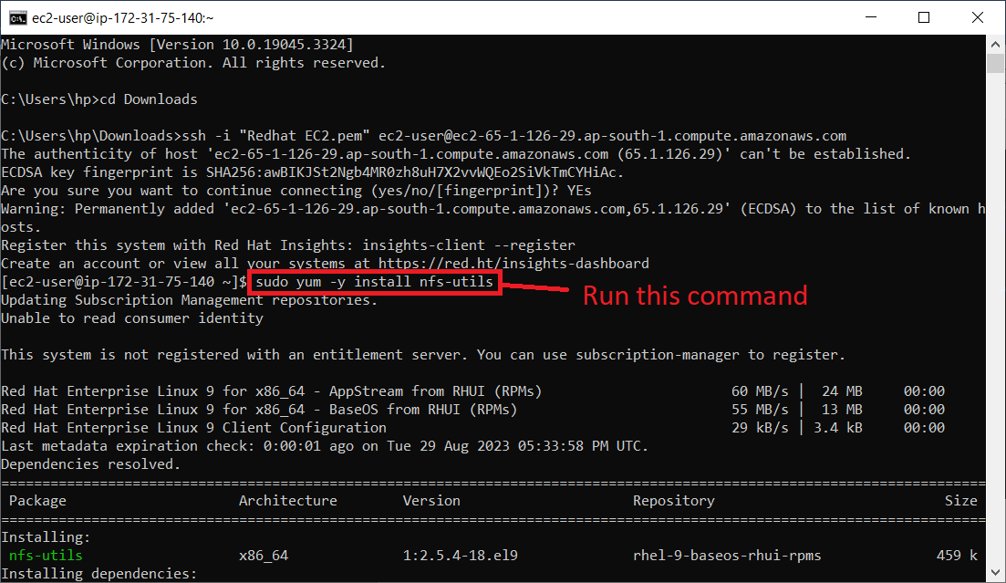

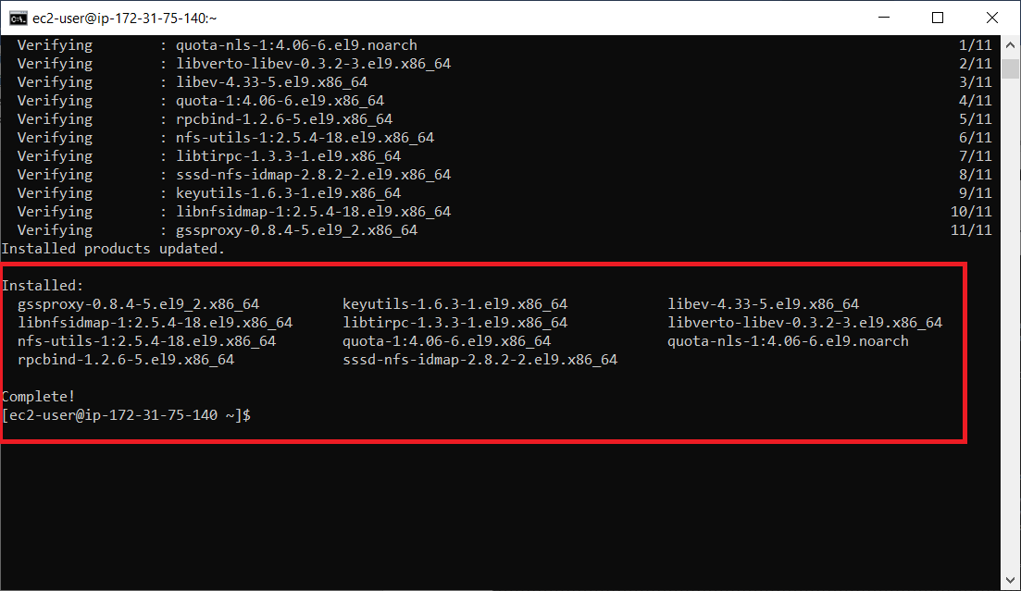

**Step 18: First, we will create a directory “new_test” using** the **“sudo mkdir new_test”.**

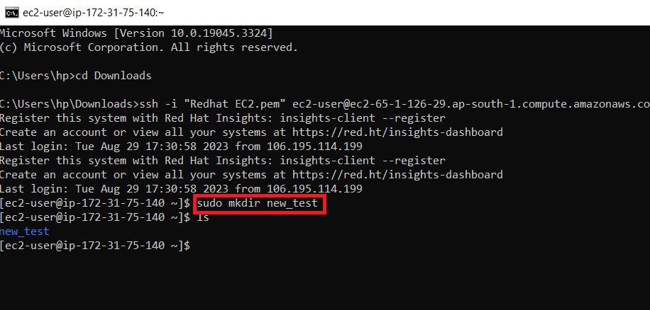

**Step 19: Now, for building** the **EFS mount, open** your **EFS File (“MyEFSFileSystem”). Click** on the **“MyEFSFileSystem”.**



**Step 20: Click** on **“Attach”.**



**Step 21: Copy** the **given command** from the **“NFS Client” system.**



**Step 22: Paste** the **“mount command”** in the **“EC2 Instance Connect”. Replace** the **efs** with **new_dir** then **hit enter** from **keyboard.**

**Command: - “sudo mount -t nfs4 -o nfsvers=4.1,rsize=1048576,wsize=1048576,hard,timeo=600,retrans=2,noresvport fs-07561978b61469e58.efs.ap-south-1.amazonaws.com:/ new_dir”**

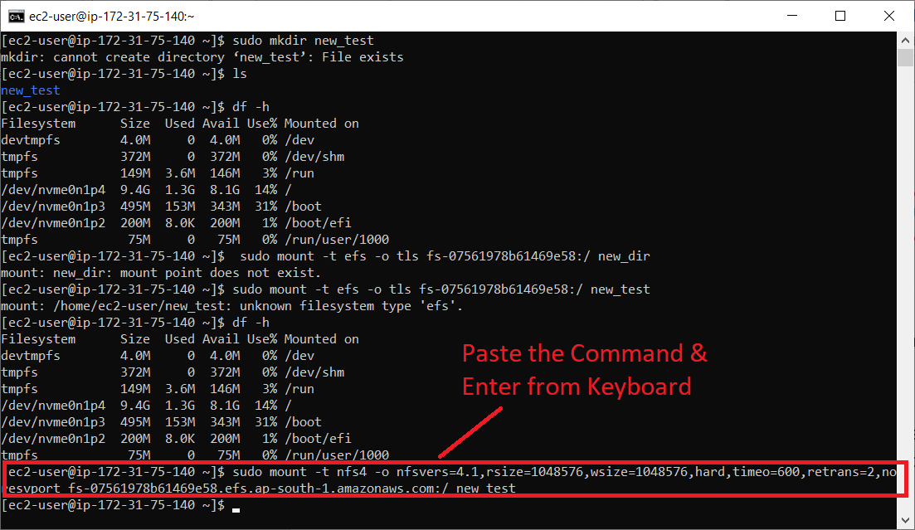

**Step 23: Now, run** the **“df -h” command** to **check** that **EFS Mount** is **build or not. The “new_test” directory** will be **shown here, it** means **your EFS mount** is **successfully build.**

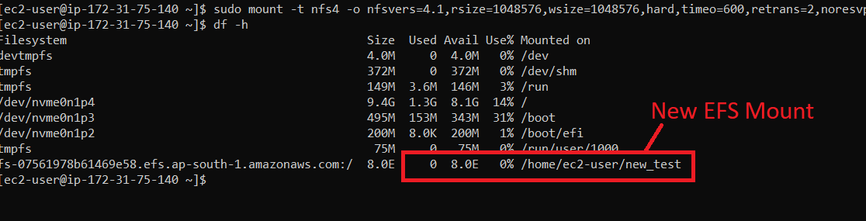

**Step 24: Now, we** will **go** intothe **new_test using** the **“cd new_test” command.**

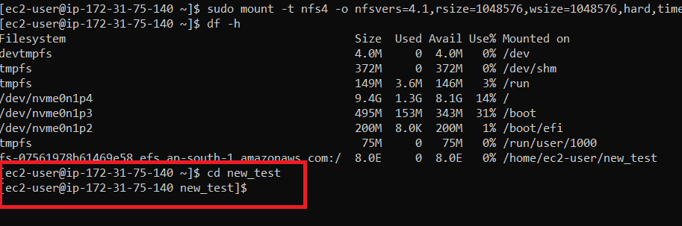

**Step 25: Now, create** a **“testing” directory** by using the **“sudo mkdir testing”** command**.**

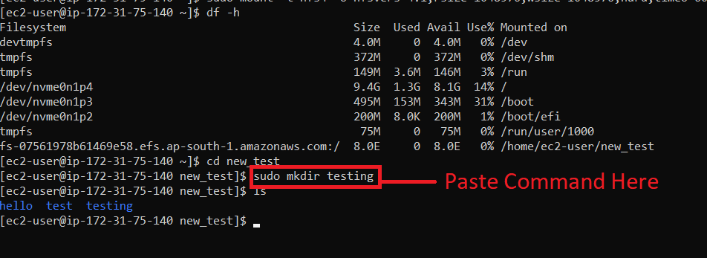

**When** we **run** the **“ls” command, it shows** us **three directories: hello (Amazon Linux Directory), test (Ubuntu), & testing (Redhat). You** can **access** these **directories** through **Amazon Linux 2** & **Ubuntu OS also.**

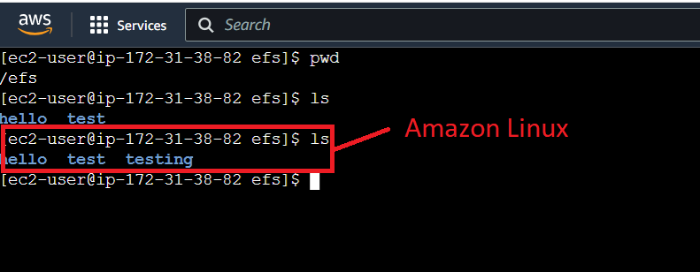

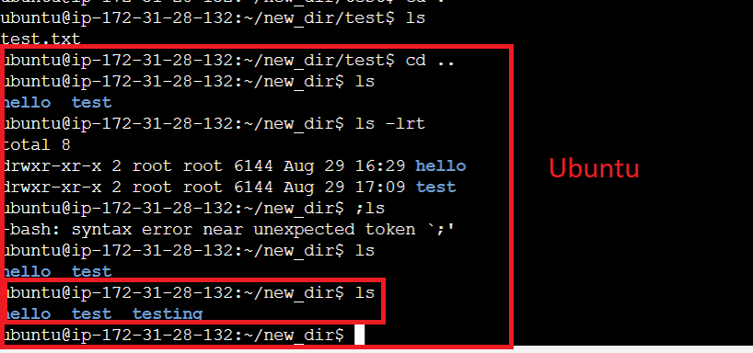

**Step 26: Now** run the **“cd testing” command** to **change** the **directory** & **go** insideintothe **“testing”** directory.

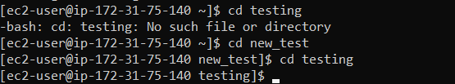

**Step 27: Now, we will create the ‘testing.txt’ file using this command (sudo touch testing.txt).**

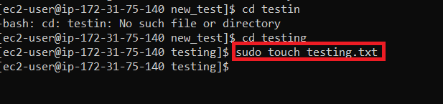

**Step 28: When we do “ls”, the “testing.txt” file will be shown.**

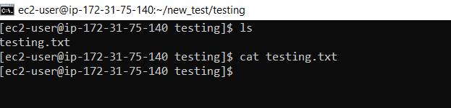

**Step 29:** **Run “sudo vi testing.txt” command to put the content over here**. & **Press the “enter” button** from the **keyboard.**

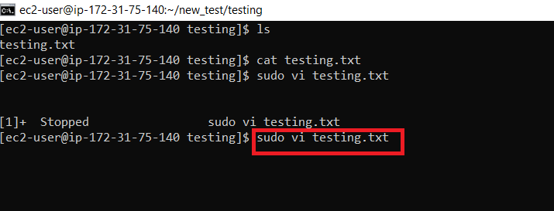

**Step 30: Paste your content in vi command editor.**

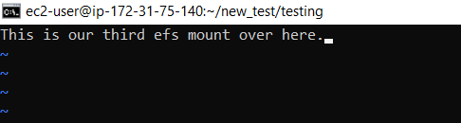

**Step 31: Press ESC button from keyboard & “type :wq!” To forcefully quit from this editor. After typing this command & press Enter from the keyboard.**

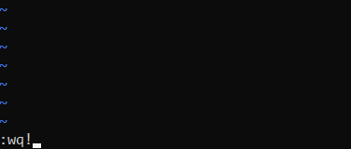

**Step 32: Run “cat testing.txt” command & you can view your content present in the testing.txt file.**

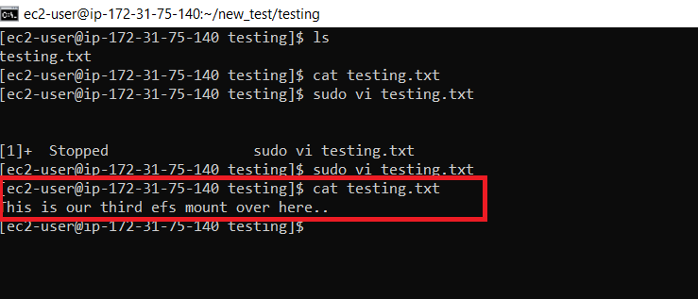

**This means we have successfully mounted on the Redhat Linux & Connect the EC2 with EFS.**

**Check these EC2 Assignments Here:**

[**How to Deploy a Sample NGINX Website on EC2 Server — EC2 Assignment 1**](https://medium.com/devops-guides/deploy-a-sample-nginx-website-on-ec2-server-ec2-assignment-1-8c2b713d9459)

[**How to Create and Attach the EBS Volume to the EC2 Instance — EC2 Assignment 2**](https://medium.com/devops-guides/how-to-create-and-attach-the-ebs-volume-to-the-ec2-instance-ec2-assignment-2-91ff64ae80ff)